

Revo Uninstaller Pro 5
User's Guide
(Updated – 5 May 2022)

OVERVIEW
Welcome to Revo Uninstaller Pro, probably the most powerful software uninstaller available. It uses multiple levels of security in a balanced way, to reduce the inherent risks associated with software removal. It uses advanced algorithms and scanning techniques to ensure the cleanest uninstalls possible without compromising security, and it makes full use of Wizards to keep all user operations as simple as possible.

Some users may just want to uninstall a few programs from time to time, whilst Power Users will wish to take full advantage of Revo Uninstaller Pro's features to remove all Bloatware that came pre-installed, unwanted browser extensions that were bundled with other software, or to delete remnants of previous failed uninstalls and broken or corrupt software. Revo Uninstaller Pro can also install new programs in a manner that guarantees a 100% clean and simple uninstall if subsequently required.

Have you ever used Windows System Restore ? It's very good, and can be extremely useful; but you have to burrow deep into your computer system to even find it. Revo Uninstaller Pro lets you find and use this plus 22 other Windows tools with just 2 simple key strokes. We've also added many of our own including one, named Hunter Mode, to uninstall or delete programs via their desktop icons.

This User Manual is designed for Inexperienced and Advanced Users, but we give the same advice to both. Take some time to read it – particularly the chapter on how Revo Uninstaller Pro works for you. It will help you understand the various steps taken by the different Uninstall processes.

Some specific advice for the Inexperienced. The first task detailed in this Guide is how to use Revo Uninstaller Pro to INSTALL a program, and create a Traced Log. Logs are the backbone of many of the features on offer, and so you are counseled to start here. Secondly, you are advised not to change any default settings in Revo Uninstaller Pro until you have gained knowledge and experience in using it.

Please note the following to help you use this Guide.
'IMPORTANT' in Red – please note/follow this advice/caution
'NOTE' in Green – more general information. Can be of a “What If” nature.
'TIP' in Bold Hyperlinks - contained within the text in Purple

CONTENTS

CONTENTS 3
1 - GRAPHIC USER INTERFACE (GUI) 4
2 - HOW REVO UNINSTALLER PRO WORKS 7
3 - FOR THE INEXPERIENCED USER 9
3.1 - Traced Programs Module - Install 9
3.2 - Traced Programs Module - Uninstall 10
3.3 - All Programs Module - Quick Uninstall 11
3.4 - All Programs Module - Uninstall 12
3.5 - Windows Apps Module - Uninstall 17
3.6 - Browser Extensions Module - Uninstall 18
3.7 - Backup Manager 19
3.8 - Uninstall History 21
4 - FOR THE ADVANCED USER 22
4.1 - The Logs Database Explained 22
4.2 - How To Manage Logs 23
4.3 - Forced Uninstall 26
4.4 - Forced MSI Uninstall 28
4.5 - Hunter Mode 29
4.6 - Traced Programs Module – Advanced Uninstall 30
4.7 - Traced Programs Module - Custom Uninstall 31
4.8 - How To Restore A Full Registry Backup 33
4.9 - Command Line support 36
4.10 - Keyboard Shortcuts 39
5 - TOOLS 41
6 - MENU/OPTIONS 56
7 – Registration/Activation and Update Subscription 64
8 – FREQUENTLY ASKED QUESTIONS (FAQ's) and TROUBLESHOOTING 68

1 - GRAPHIC USER INTERFACE (GUI)

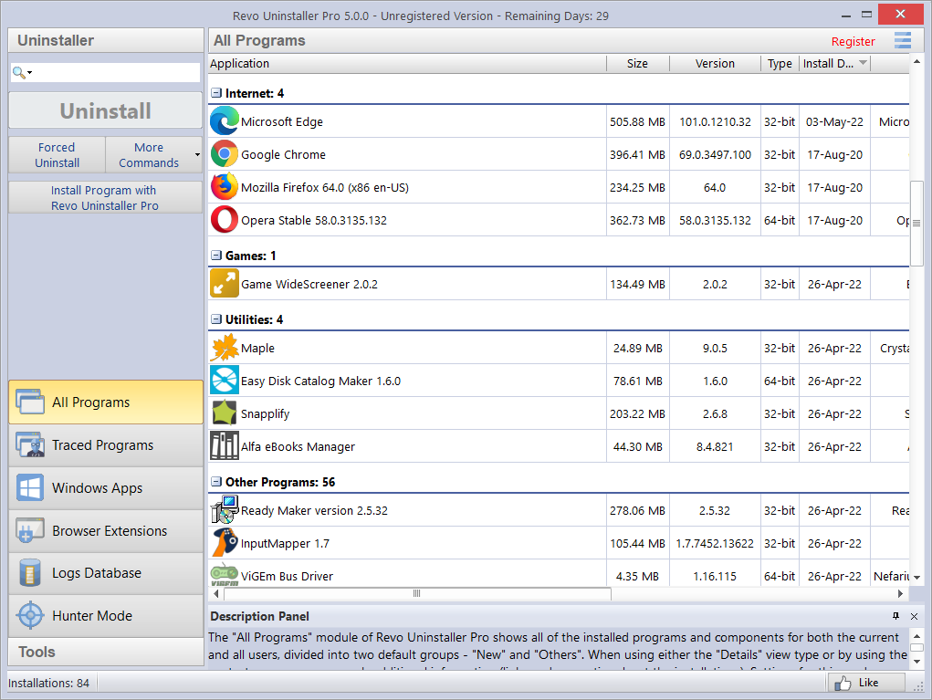

This shows a Details Panel and a Commands Panel divided in two. The upper part shows commands for the active tool (All Programs shown here) with principle commands shown as separate buttons. Others are found inside the More Commands button, or the tool window context menu. The lower part shows 2 groups of modules, Uninstaller and Tools. Clicking on one will switch to the other. To open a module, click its button.

Left click on a column header to sort its contents order. Right click to open a context menu offering the ability to display/hide columns, and to realign their text. Click on the magnifier in the Search field in the Commands Panel, to filter software in real time - by name, publisher, or comment.

The Description Panel informs about the active tool. It can be dragged anywhere in its window. An Auto Hide feature will show the panel only on mouse over. Simply press the small button with the shape of a pin in the upper right corner of the Description Panel.

Dependent upon the module/tool selected, the Status Bar (sited under the Description Panel) may show additional information.

The Menu button is located in the top right hand corner of the GUI. It contains both essential and general commands, including user Options for the whole program.

By default, installed programs are displayed in Details view, as above. System updates and system components can also be displayed, (Menu->Options->All Programs).

NOTE: The Print command in More Commands works only in Details view, and is best in landscape.

Revo Uninstaller Pro can export installed programs to TXT, HTML, CSV, XML and XLS (Microsoft Excel spreadsheet). (More commands->Export List to). You can choose what information will be included in the exported file.

NOTE: To export installed programs to a Microsoft Excel spreadsheet you must have Microsoft Excel installed and correctly working.

Click Refresh in More Commands to resolve any issues with the listing of all installed programs. If this doesn't fix the issue, you may need to rebuild the installed programs data file; (Menu->Options->All Programs) and then click the “Rebuild cache file” command highlighted in blue.

IMPORTANT: Rebuilding the cache file resets any user customization for the program list, so comments, custom icons, and group associations will be removed.

You can assign each program to a group (Menu->Options->Groups Manager) or right click on the program (or Log) to access it's context menu. Both the All Programs and Traced Programs modules share some menu items, whilst others are unique.

Upon first launch of the program, you will be asked to choose between the default/classic or the dark user interface mode of Revo Uninstaller Pro. The user interface colors can be customized separately, either manually or by using predefined themes, with an included Dark Mode (Menu->Options->View->Theme).

Details are explained in the specific Uninstall chapters.

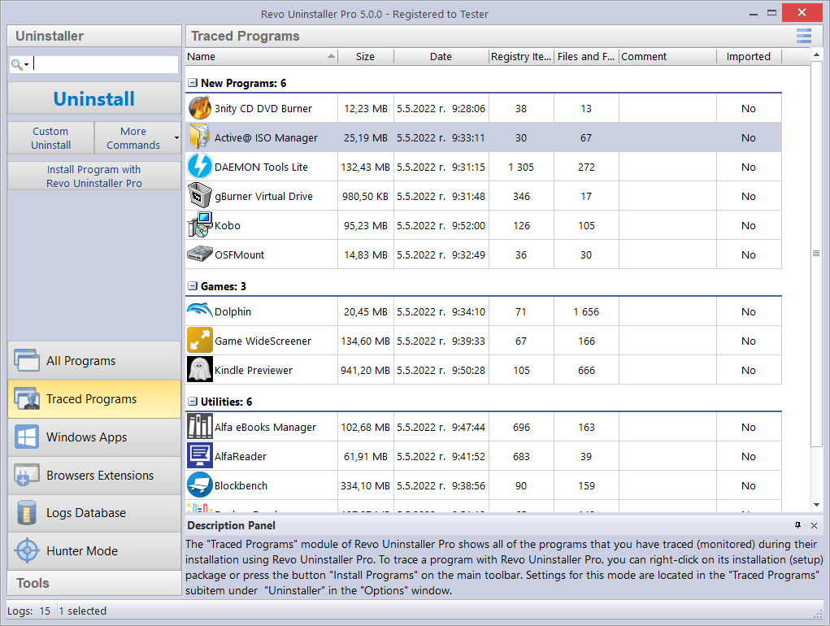

View settings can be customized (More Commands->View) to show a List or Icons.

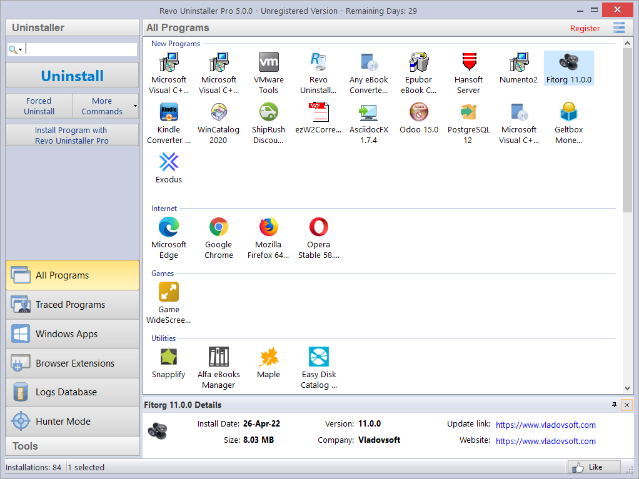

2 - HOW REVO UNINSTALLER PRO WORKS

Specific tasks will vary, dependent upon which Uninstall feature you choose to use. Steps 1 and 2 are, essentially, conducted by Revo Uninstaller Pro, although you may be asked to confirm some actions.

Step 1 Analyze-> Step 2 Run Built-in Uninstaller-> Step 3 Scan-> Step 4 Removal ->Step 5 Summary

Revo Uninstaller Pro will usually analyze the installed program you wish to remove using advanced algorithms to find all composite items, including Files, Folders, EXE's, DLL's, Registry items and Key Values that make up the program. It may, instead, make use of Traced Logs. It starts this process when you launch any Uninstall task.

Step 1 Analyze-> Step 2 Run Built-in Uninstaller-> Step 3 Scan-> Step 4 Removal ->Step 5 Summary

Revo Uninstaller Pro will create a full Registry backup (unless option disabled) and a System Restore Point, and then run the built-in uninstaller of the program you are removing. An Uninstall Wizard, specific to the uninstall option, will show progress. Substitute options are offered when there is no built-in uninstaller.

Step 1 Analyze-> Step 2 Run Built-in Uninstaller-> Step 3 Scan-> Step 4 Removal ->Step 5 Summary

Dependent upon the uninstall process selected, you can set the Scan intensity level to search for leftover program items including Registry keys, files and folders. If enabled in the Options, during leftover scan, you will also be able to select an option to scan all Windows accounts for leftovers.

Step 1 Analyze-> Step 2 Run Built-in Uninstaller-> Step 3 Scan-> Step 4 Removal ->Step 5 Summary

Revo Uninstaller Pro will complete the removal process automatically if you use the Traced Uninstall, Quick Uninstall commands or turn on the option “Automatically delete all found leftovers”. All other Uninstall options reflect some level of user input dependent upon whether you are performing a straightforward removal or, for example, the removal of a corrupt or broken program. Different Uninstall options may provide other specific information tools to assist you in your decision making.
Otherwise, after the scan is complete, leftover Registry items will be shown in a new window with leftover files and folders in a different window. You are now free to select those you wish to remove.

Step 1 Analyze-> Step 2 Run Built-in Uninstaller-> Step 3 Scan-> Step 4 Removal ->Step 5 Summary

If you are not using an automatic removal process, as the last step of the uninstall process you will see a Summary screen with on overview of the completed operation, showing basic information about successfully and unsuccessfully deleted files, folders and Registry entries. There is an added option to review this information in detail. After closing the Summary screen, this information can be accessed at any point from the corresponding Uninstall History section for each module (All Programs, Traced Programs, Windows Apps, Browser Extensions, Forced Uninstall), which stores data for all complete or partial uninstall operations.

TABLE SHOWING ALL UNINSTALL TASKS

Module (Chapter) | Task | Step 3 - Scan | Step 4 - Removal
INEXPERIENCED
Traced Programs - 3.1 | Install | Not Applicable | Not Applicable
Traced Programs - 3.2 | Uninstall | Automatic | Automatic
All Programs - 3.3 | Quick Uninstall | Preset to Moderate | "
All Programs - 3.4 | Uninstall | " | Standard Procedure
Windows Apps - 3.5 | Uninstall | " | "
Windows Apps - 3.5 | Quick Uninstall | " | "
Browser Extensions - 3.6 | Uninstall | " | "
Browser Extensions - 3.6 | Remove | Not Applicable | Automatic
ADVANCED
Logs Database - 4.1 | Uninstall | Automatic | Automatic
Logs Database - 4.1 | Custom Uninstall | See chapter 4.7 | See chapter 4.7
All Programs - 4.3 | Forced Uninstall | Free Choice | Standard Procedure
All Programs - 4.4 | Forced MSI Uninstall | Preset to Moderate | Standard Procedure
Hunter Mode - 4.5 | Forced Uninstall | Free Choice | Standard Procedure
Traced Programs - 4.6 | Advanced Uninstall | Automatic | Standard Procedure
Traced Programs - 4.7 | Custom Uninstall | Free Choice | Standard Procedure

The removal process in Step 4 for all users is entitled “Standard Procedure”. It should be clearly understood that the leftover Registry items, files and folders detailed reflect the selected scan level applied in Step 3.

IMPORTANT: Inexperienced Users are recommended to stay with Moderate.

Advanced Users will undoubtedly prefer to select the Advanced level, which requires a more detailed analysis by the User before confirming items for removal.
When uninstalling programs, advanced users have the option to scan all Windows accounts for leftovers. If the option is selected, Revo Uninstaller Pro will scan for leftovers the current, as well as any and all other standard user or administrator accounts on the computer.

3 - FOR THE INEXPERIENCED USER

3.1 - Traced Programs Module - Install

This feature takes just a few seconds to start, and then monitors program installs in real-time. It detects and records all system changes. This record is called a Traced Log.

TIP: We recommend that you use this feature to install all new programs, since possession of a traced log offers the easiest way to uninstall a program.

IMPORTANT: To Guarantee an Accurate, Clean TRACED LOG:
1. - Only install one program at a time
2. - Do not run or start any other programs during the installation. However, you do not need to stop any programs already running.

You have two Install options:
1 - Right click the program setup file, select Install with Revo Uninstaller Pro
or 2. - start Revo Uninstaller Pro and in either the All Programs or Traced Programs modules, select the Install Program with Revo Uninstaller Pro command, and browse to the program setup file.

The program install will start as normal and a toolbar will appear at the top of your screen.
TIP: You can switch the wide toolbar (Trace Bar) to a smaller one. Menu -> Options -> Traced Programs -> Trace programs in compact mode.

3. - Complete the program install as usual, then immediately run and configure it. Repeat configure for any other program components. Close the newly installed program. 4. - Click the Stop button on the Trace Bar. Revo Uninstaller Pro will suggest a name for the log. Keep or change the name as you wish, and click the Save button. This name will be detailed in the Traced Programs module.
NOTE: Some programs require computer rebooting before you can run them for the first time. If so, press the Stop and Save buttons on the Trace Bar and reboot. Revo Uninstaller Pro can detect system reboots, and will save the log automatically, although in such a case the name of the log will be chosen by Revo Uninstaller Pro

3.2 - Traced Programs Module - Uninstall

NOTE: Use of a program's Traced Log eliminates the need for Revo Uninstaller Pro to run any advanced scanning techniques when uninstalling the same program, yet guarantees a 100% clean uninstall just as if it had never been installed at all.

This is the easiest way to uninstall a program. Click the Uninstall button of a logged program and Revo Uninstaller Pro will do the rest.

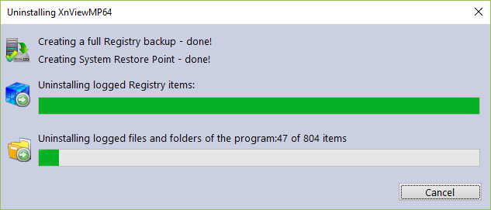

The uninstall wizard will display progress and close automatically once the uninstall completes. By default, all deleted Registry items are backed up.

TIP: To backup deleted files & folders, amend the setting in Menu -> Options -> Uninstaller.

3.3 - All Programs Module - Quick Uninstall

Another simple way to uninstall a program. Simply choose the one you wish to remove, select the More Commands button, and left click on Quick Uninstall. If applicable, the built-in uninstaller of the program will run silently in the background. You will be prompted to confirm you wish to delete the chosen program, and to Continue the uninstall before receiving a notification to say “Finished”.

We recommend you leave the scan mode set to Moderate, although you have the option to choose Safe or Advanced.

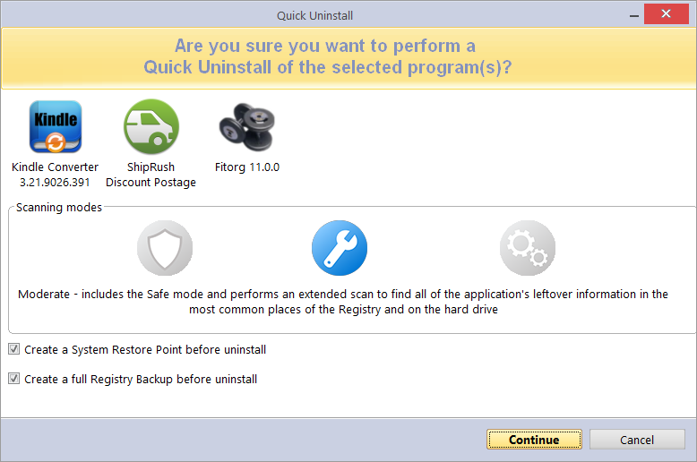

You can also remove multiple programs consecutively with just one set of actions. Simply hold the “Crtl” button and select the programs you wish to remove or select them using the check boxes in front of the listed programs. The Uninstall button will automatically switch to the Quick Uninstall button. Left click and Revo Uninstaller Pro will operate as before with just one slight difference. The built-in uninstaller of the first program/app will be launched (silently, if possible, in order to automate the process), followed by an automatic scan and removal of leftovers. If the built-in uninstaller fails to launch or takes too long to do so, you will be allowed to click the “Continue” button to proceed directly to the leftover scan. After the first program/app is uninstalled, Revo Uninstaller Pro will proceed with the removal of the second program or app in the queue, etc. Therefore, the System Restore Point and full Registry Backup will be performed only once – at the very beginning. At the end of the uninstall operation, a summary will be presented to you.

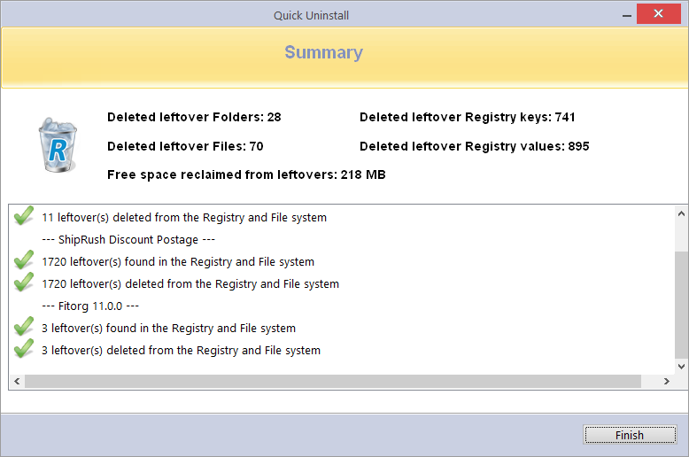

NOTE: Quick Uninstall silently scans for any leftover items in the background, and then automatically deletes them. By default, all deleted Registry entries are backed up in the Backup Manager, and deleted leftover Files and Folders are moved to the Recycle Bin.

3.4 - All Programs Module - Uninstall

The most popular method employed by our Users. Select a program to remove, and left click on the Uninstall button. An uninstall wizard will open and indicate progress.
NOTE: Revo Uninstaller Pro will silently search the Logs Database for matching trace log(s) to the program you are removing, or for logs you have personally traced or imported.
1. - If a single log is found, and Revo Uninstaller Pro decides to use it, you will be informed at stage 2 of the Uninstall Wizard.
2. - If several are found, you will be asked if you wish to use them.

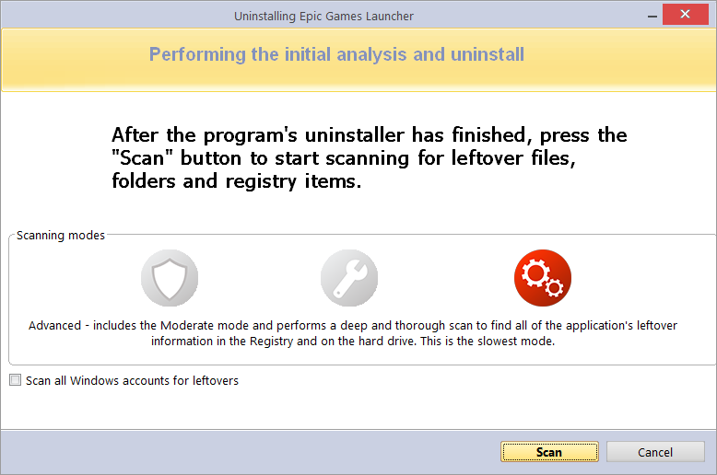

Revo Uninstaller Pro will create a full Registry backup (unless disabled in Options), a System Restore Point (unless disabled in Options), and then run the built-in uninstaller of the program you are removing. You may be asked to confirm this.

TIP: The built-in uninstaller may show up behind other open windows. If so – hold the Alt key and press the Tab key to cycle between windows.

NOTE: Continue Uninstall after system restart - If the Uninstall Wizard is open and the computer automatically reboots, either at the request of the program's built-in uninstaller, or for some other reason – don't worry. Revo Uninstaller Pro will store the uninstall data, and offer to continue the unfinished uninstall the next time the computer is restarted. You will see a message offering to either continue, postpone, or simply cancel the procedure.

After the built-in uninstaller has finished, click the Scan button to continue the removal process. You are reminded to set the scan to Moderate at this stage of your learning.

NOTE: There are 3 scan levels modes:
Safe - performs a scan of the Registry and the hard drive to find leftover data to delete. This is the fastest mode.
Moderate - includes the Safe mode, and performs an extended scan to find all leftover data in the most common places in the Registry and on the hard drive.
Advanced - includes the Moderate mode, and performs a deep, thorough scan to find all leftover data in the Registry and on the hard drive. This is the slowest mode.

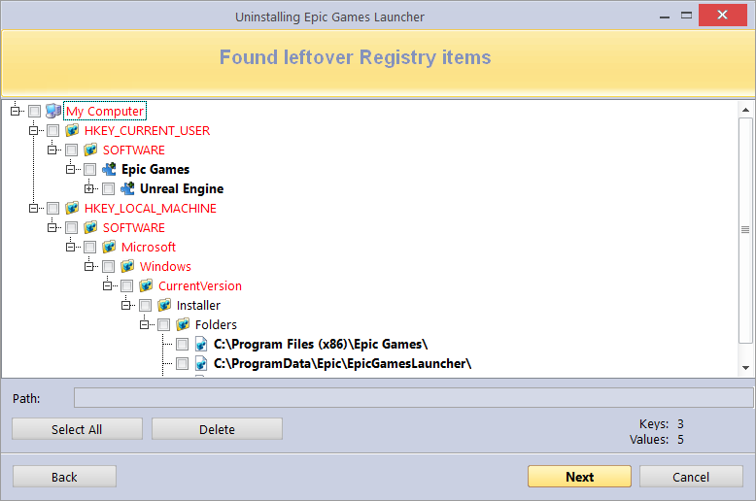

After the scan is complete, Registry items will be shown in a new window. Registry keys and values created by the uninstalled program are highlighted in Bold. Items in red will never be deleted.

NOTE: All others shown are considered not to have been created by the uninstalled program. They are displayed:

1. - To give you a better idea of the tree structure.
2. - To make for easy and fast selection of leftover items for deletion.

NOTE: Revo Uninstaller Pro contains many safety mechanisms and it does NOT list leftover items if deleting them could harm your system. So, although it does a better job than Windows’s “Programs & Features”, and the built-in uninstaller of the software you remove, it may still miss some leftover items. It is better to be safe than sorry.

IMPORTANT: You have to check items that you want to uninstall.

TIP: A check of a parent branch of items will automatically check all it's children.

Many leftover items are easily distinguished by name, by install path, etc. GUIDs and CLSIDs (alphanumeric items) are correct leftover items most (99%) of the time, and so you can safely delete them.

TIP: Right click any item to open a context menu to help manage your decision making. Most options are self explanatory, but note the following:

Expand All/Collapse All – expands and collapses all items in the Registry tree. Open Registry Key… – opens the key in the Windows Registry (regedit.exe). Uninstall Selected Key – deletes the key from the Windows Registry
IMPORTANT: Only for use by Advanced Users when conducting a Custom or Advanced Uninstall.

Add to Exclude List – adds the selected key to protect from deletion, and marks it in red. You can edit the exclude list from the Options menu. Mark selected key as Created – is useful when you positively identify a Registry key, as created by the program being removed, but not marked as created because of the safety algorithms within Revo Uninstaller Pro.
IMPORTANT: Only mark the key if you are absolutely certain that it belongs to the uninstalled program!

If, at this stage, you prefer to change the scanning mode, click the Back button, and return to the previous step, select a new scanning mode, and press Scan again to continue.

TIP: Whether you click on the Select All button or check each item individually, be reassured that when you press the Delete button, only entries that are checked and in bold will actually be deleted. The deleted Registry entries are also backed up, and if needed later, you can restore them using the Backup Manager.

NOTE: Very occasionally, and normally only in Advanced scanning mode, Registry items relating to other programs may be displayed.

If for example:-
1. - You installed 2 versions of the same program. Say "Adobe Photoshop CS" & "Adobe Photoshop CS5". In this example, you can possibly distinguish leftover items by their description.
2. - You wish to remove a single component of a larger software package such as Excel, part of Microsoft Office. In this example, Revo Uninstaller Pro could list the rest of the components (Word, PowerPoint etc) as leftover items as they are in the same program folder, and thus could not distinguish the difference.

It would be better to allow Revo Uninstaller Pro to remove the entire software package.

After removing the leftover Registry items, click the Next button, and continue to the leftover files and folders window. The Next button is unavailable if none are found.

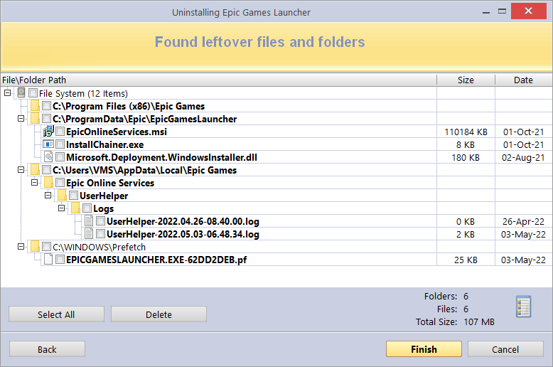

Leftover files and folders are identified by name, and can be deleted as necessary.
TIP: Right click any file or folder to obtain a context menu to help manage your decision making.
TIP: To backup deleted files & folders, amend the setting in Options -> Uninstaller.

Click the Select All button to check all leftover files and folders, then click the Delete button to remove them to the Recycle Bin. You can change this setting in Options -> All Programs.

You can switch the view of leftovers from a tree to a list using the icon on the right of the properties of found leftovers. After removing the leftover files and folders, click the Next button, and continue to the Summary window to review the results of the uninstall operation.

3.5 - Windows Apps Module - Uninstall

The main window displays pre-installed and downloaded Apps. To customize, visit Chapter 1 - the GUI.

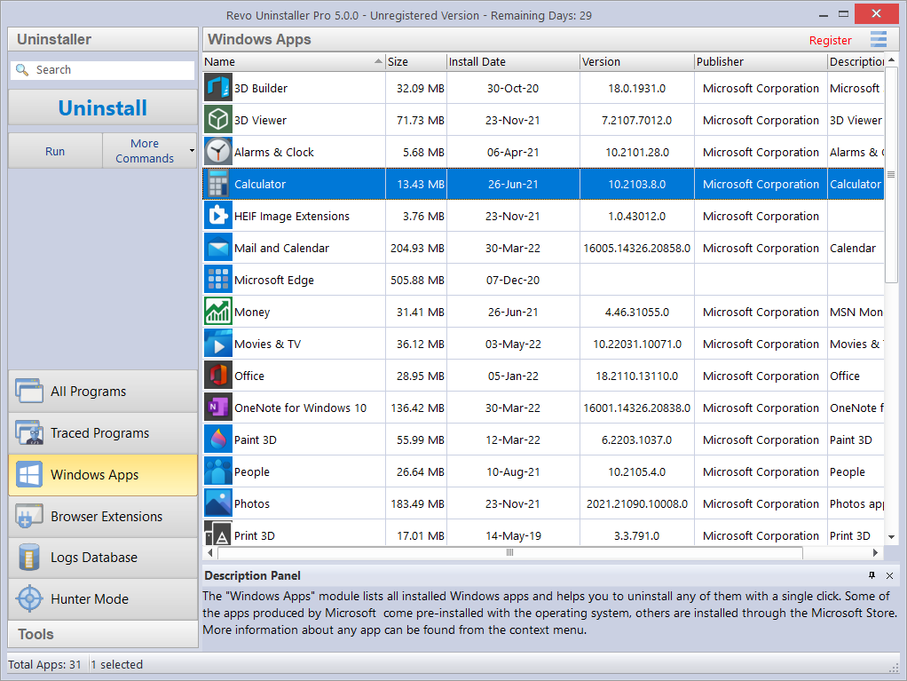

NOTE: To export installed apps list to a Microsoft Excel spreadsheet you must have Microsoft Excel installed and correctly working.

Click on the list or the Search field in the Commands Panel, to filter Apps in real time by name. Select the App to remove and left click the Uninstall button. An uninstall wizard will open and indicate progress. If you are not sure what the listed App is, you can use use the Run button from its context menu to launch it.
Right clicking an App will give you the option to uninstall it from all user accounts, to forcibly stop it (using the Terminate command) or to Reset the App to its initial state with default settings.

Revo Uninstaller Pro will create a full Registry backup (unless disabled in Options) a System Restore Point (unless disabled in Options), and then uninstall the App. If the App or part of it is successfully uninstalled, an entry will be added to the Uninstall History section in Windows Apps module.

If you are experiencing issues with Microsoft Store in general, it can also be reset using the Reset Microsoft Store command from the More Commands button.

After the uninstall completes, click the Scan button to search for leftover items, as fully detailed in the later sections of chapter 3.4 – All Programs module Uninstall.

You can uninstall multiple Apps at once by using the the Quick Uninstall command, which is fully detailed in chapter 3.3 – All Programs module Quick Uninstall.

3.6 - Browser Extensions Module - Uninstall

The main window lists all browser extensions that were either bundled with other software or installed separately. These extensions or add-ons are grouped by browser name. Revo Uninstaller Pro currently supports Google Chrome, Mozilla Firefox, Microsoft Internet Explorer, and Microsoft Edge.

To customize the view, visit Chapter 1 - the GUI.

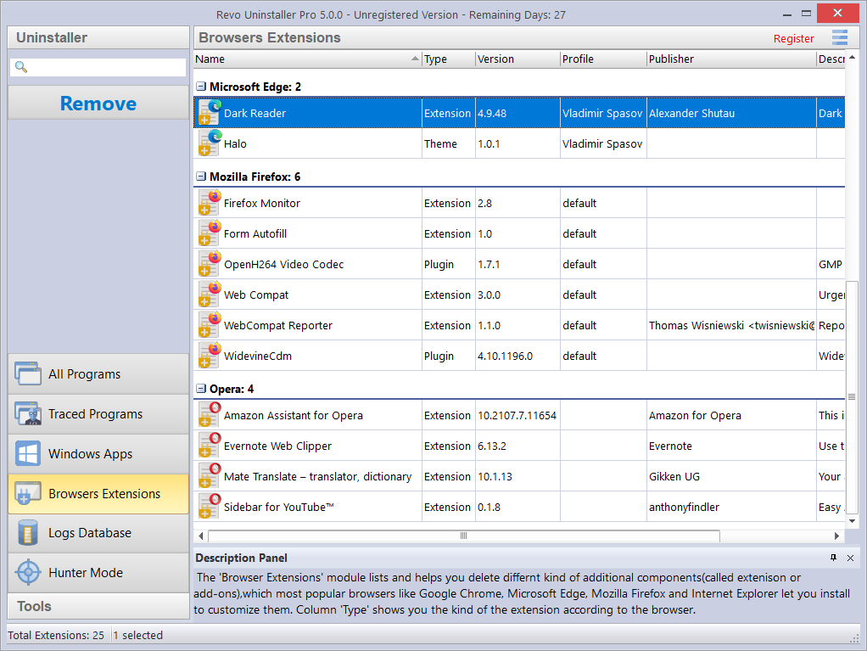

Click on the list or the Search field in the Commands Panel, to filter Extensions in real time by name.

Now, simply select one or more extensions to uninstall and left click the Remove button. Job done.

Intuitive commands are available from the context menus for the main header columns, and the individual browser extensions.

TIP: Click Refresh to reload the Browser Extensions list.

3.7 - Backup Manager

Revo Uninstaller Pro automatically records all deleted Registry items during all Uninstall procedures and the Autorun Manager, but not for files and folders. This is because the backups can be large in size, and this may not be practical.

TIP: To backup deleted files & folders, amend the setting (Options -> Uninstaller-> Delete files and folders to Backup folder).
TIP: You can delete all or just some of the backed up data if you need to free up disk space.
NOTE: By default, Revo Uninstaller Pro also creates a Windows Restore Point at the start of any uninstall operation (before deleting any data).

Backups are created for the same reason that you should regularly back up your personal data, and why your Windows system also creates daily Restore Points: To help you resolve a problem. The vast majority of problems can usually be overcome by performing a Windows Restore operation. Backup Manager is there for the very rare occasion when Windows Restore doesn't help.

Imagine, for example, that Revo Uninstaller Pro deleted a Registry key of another program by “error”, or perhaps you mistakenly selected a key by error when performing an Uninstall operation. Now is the time to use Backup Manager. Just open the relevant backup and restore the key(s) – it takes very little time and is very simple.

When restoring backed up items, you can choose to restore all or just some of the deleted data. To start Backup Manager click its button in the Tools group in the lower part of the Commands Panel.

The main window details all locally stored backups grouped by creation date, then sequenced by time. Each backup details the operation during which the item was backed up, it's size, and the number of items copied.
Click left on any column header to change the sort sequence. Click right to view a context menu offering visual customization.

Click right on any backup to obtain the options to Restore/Custom Restore/Delete.

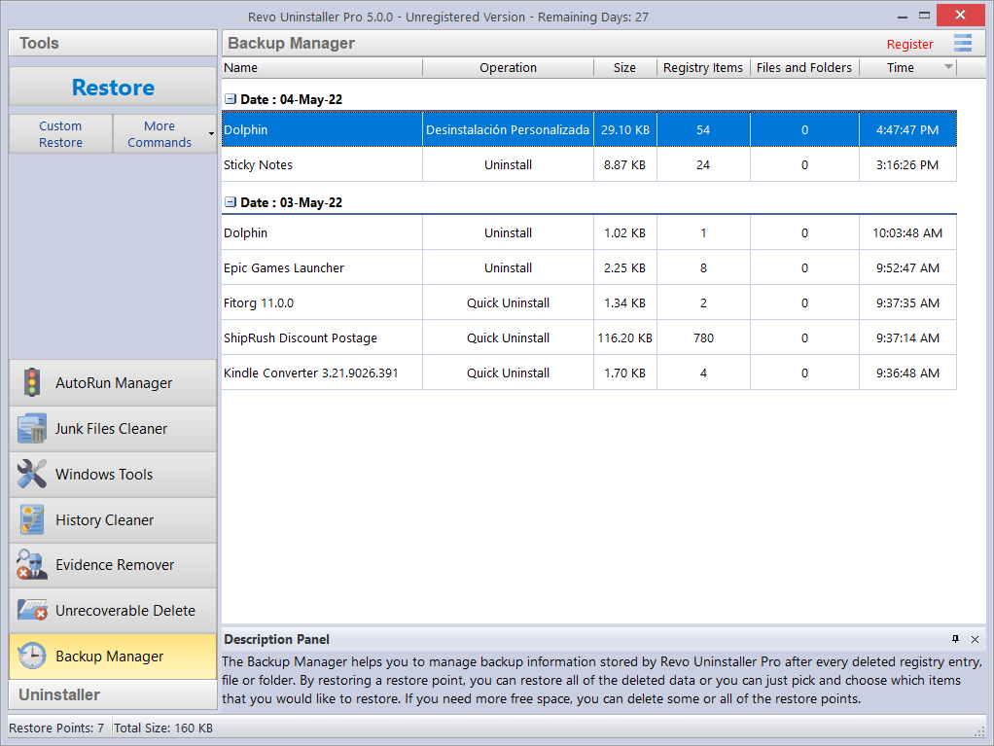

Click on More Commands to obtain the options to Delete/Delete by Time/Delete All/Windows Restore System.

Restore - restores all backed up items. There is a progress bar. When restoration completes, the window will close automatically.
Custom Restore - allows selective restore of specific Registry items (first), and selective files and/or folders (second). Dependent upon whether files and folders are also backed up by the Backup Manager. Simply check the items you want to restore, and click the Restore button. You can also click the Select All button, and then Restore.
Delete - removes the selected backup to the Recycle Bin.
Delete by Time - opens a window that allows you to delete multiple backups, based on their creation date. You can delete all backups in a specified period of time, or all backups before a specified date.
Delete All - removes all backups from the list, and moves them to the Recycle Bin.
Since all backups are deleted to the Recycle Bin, if you want to free up disk space, you will need to empty the Recycle Bin.
Windows Restore System - opens a shortcut link to Windows Restore just as detailed in the Tool section chapter 5.6.1 - Windows Restore.

3.8 - Uninstall History

Revo Uninstaller Pro keeps detailed records about uninstalled programs and apps in a new section called Uninstall History. It can be accessed from the More Commands button in each module where it is applicable – All Programs, Traced Programs, and Windows Apps.
The records in the Uninstall History are grouped by date, and then further sorted by time. Each record indicates the operation used to uninstall the software (e.g. Uninstall, Forced Uninstall, Trace Log, etc.).

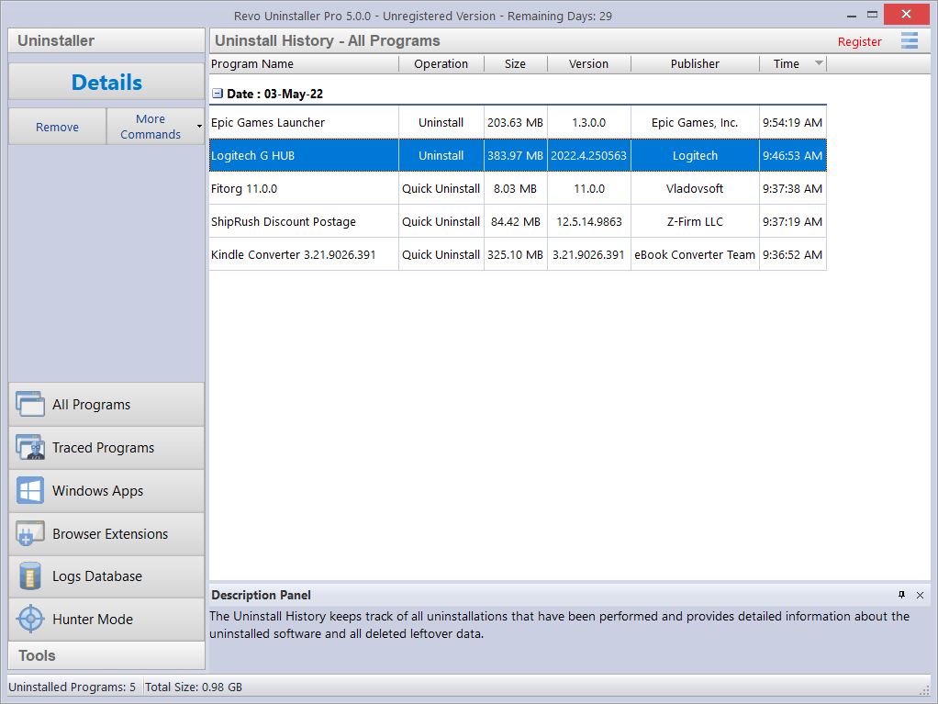
Opening each record reveals general information about the program, as well as a full list of all successfully and unsuccessfully deleted leftover files, folders, and Registry keys and values, with the added option to also export this information to a text file.

TIP: You can delete all or individual records if you need to free up disk space, or if you simply do not need them.

4 - FOR THE ADVANCED USER

4.1 - The Logs Database Explained

Revo Uninstaller Pro can also install programs for you. It monitors the process in real time, and will detect and record all system changes to the program install. This record is known as a Traced Log, and all such logs are listed in the Traced Programs module. We recommend you use this feature to install all new programs, since possession of a traced log offers the easiest way to uninstall a program.

TIP: Visit chapters 3.1 and 3.2 to view these very simple procedures.

The team at Revo Uninstaller Pro have created tens of thousands of such logs for popular and requested programs, and have uploaded them to our web server. This is the Logs Database. It is automatically updated via your internet connection. This means that even if you have no traced logs for your existing programs, you can still obtain a clean uninstall using the logs within the Logs Database.

NOTE: Remember, you manage the logs in the Traced Programs module, whilst we create and maintain the Logs Database.

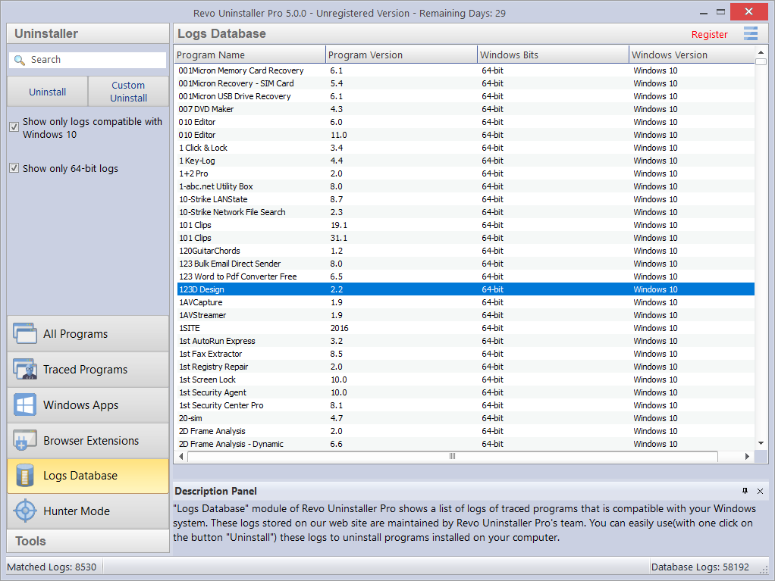

By default, the Logs Database, will only list those compatible with your version and architecture of Windows. You can change these options in the Commands Panel under the Search field. The number in the left side of the status bar details how many programs are listed dependent upon the current filter settings and search terms entered. The number to the right side details the total number of logs in the Logs Database.
Click on the magnifier in the Search field to filter logs in real time by name. The status bar will display the number of programs that match the search criteria.

There are only two commands in the Logs Database - Uninstall and Custom Uninstall.

1. - Select a program in the Logs Database and click on the Uninstall button to download it. Revo Uninstaller Pro will remove the program, and delete the log. Job done. 2. - Select a program in the Logs Database and click on the Custom Uninstall button to download it. The full procedure is detailed in chapter 4.7 – Custom Uninstall.

NOTE: If you wish, you can import a log from another user into the Traced Programs module and perform the same two procedures from there. The Import Log and Export Log commands inside the Traced Programs module let you share with anyone else using Revo Uninstaller Pro. See chapter 4.2 below – How To Manage Logs

TIP: If the program you are searching for is small but not listed in the Logs Database for your specific Windows version, try removing the check mark for the option Show only logs compatible with xxx [your Windows version]. If the program log now appears, then you should be able to remove the program successfully.

4.2 - How To Manage Logs

Click Manage in Traced Programs->More Commands for the context menu options:

TIP: For multiple logs, simply hold the Crtl button and select as required.

Delete Log(s) – offers a simple delete of the log(s) from the list and the hard drive. This does not affect the installed program(s).
Merge selected logs – combines all data into a single log. The newest log(s) will be inserted into the oldest one. When complete, the name of the oldest log will be retained. Keep or change as you wish. The newer log(s) - whose data was merged - is/are deleted.

NOTE: Why merge logs ? Imagine that over time you have installed different versions of the same program, and each time created a log. You can now merge them into one log, and perform just one Traced Log uninstall. Similarly, you could merge logs for different programs of a given company. This could be of assistance to a Technician, for example.

Rename Log - lets you change the name of any log in the list.
Export Log – allows you to export a traced log (in .ruel format) for future import. Imagine you have problems uninstalling Program A or just seeking a better uninstall, and a friend of yours has installed and traced the same program also using Revo Uninstaller Pro. He can export his log to you and you can import and use it just as any other traced log.
Import Log – opens a dialog window allowing you to select exported traced log files (in .ruel format). After importing, the log will appear in the Traced Programs module, alongside any trace logs you have already created.
An alternative way to import an exported log file is to double click on it in your file manager, since Revo Uninstaller Pro is associated with .ruel files.

IMPORTANT: Revo Uninstaller Pro must be closed for importing to work.

Edit Log - opens a window letting you change data in the log.

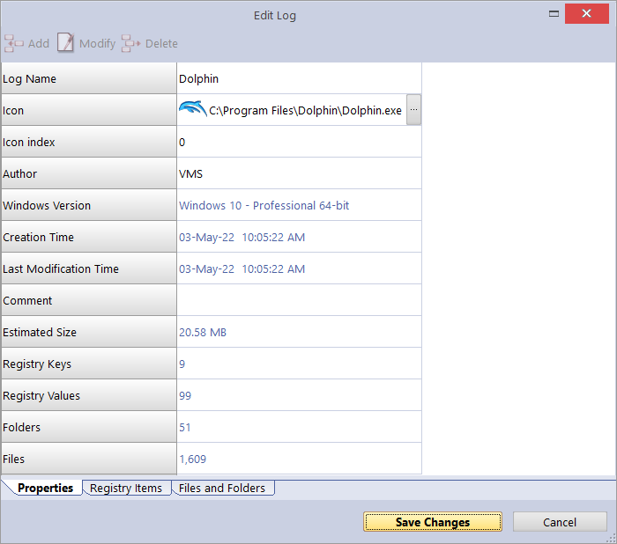

There are three tabs:
Tab 1 - Properties – contains general information about the trace log. You can review and edit the Name, Icon, Author, and Comment fields. All other listed fields are read-only; but their data will change if you make changes to the trace log itself.

Tab 2. - Registry Items – lets you view and modify Registry keys and their values held within the trace log. The left part of a two-part window shows all Registry keys in a tree-like structure, with the right showing the corresponding value for the selected key. Modifications are made using the toolbar commands at the top of the window:
Add Value/Key – lets you add Registry keys and values to the trace log. To do so, you must first select a key within the tree structure to be the parent of the new added item.
Modify – lets you modify the data of a Registry key or value. Select the entry, click Modify, and make the desired changes.
Delete – lets you delete a Registry key or value from the trace log.
NOTE: This does not affect any data in the Registry of your operating system.
Export list to HTML - exports the data from the opened tab to an HTML file.

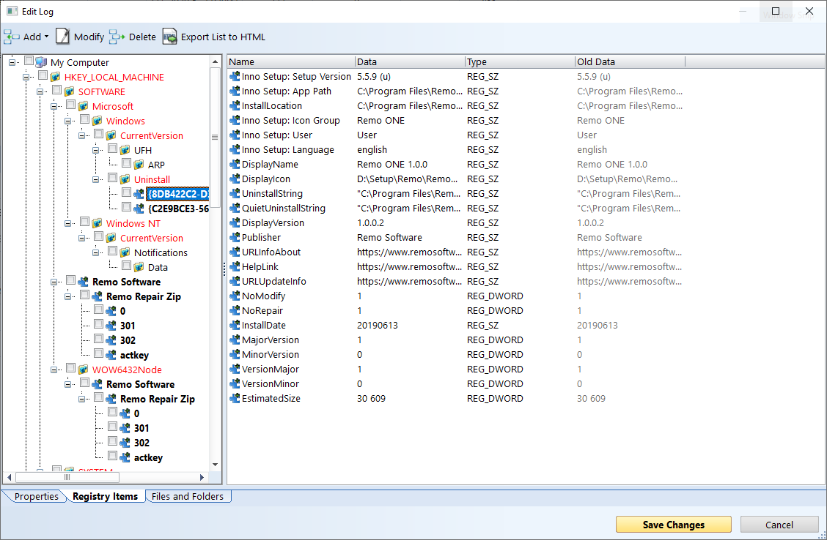

Tab 3. - Files and Folders – lets you view and modify files and folders held within the traced log. They are displayed in a simple list. Modifications are made using the toolbar commands at the top of the window:
Add File/Folder - lets you add files and folders to the trace log. To do so, you must first select a folder within the tree structure to be the parent of the new added item.
Modify - lets you modify a few properties of a file or folder, namely it's name and whether it was created or renamed.
Delete – lets you delete a file or folder from the trace log. NOTE: This does not affect any data on your hard or SSD drive.
Export list to HTML - exports the data from the opened tab to an HTML file.

NOTE: The context menu commands and the meaning of the colored and/or bold items in the tree structure and list is the same as described in chapter 4.7 – Custom Uninstall.

4.3 - Forced Uninstall

This feature helps you remove leftovers of programs that have been previously uninstalled (before Revo Uninstaller Pro was first used), or have been incompletely installed or uninstalled, and remnants still remain. It will even work if the program is not listed.
To start, open the All Programs module and click the Forced Uninstall button in the command field.
Forced Uninstall requires at least one of two parameters to get the job done:

1 - the exact program name. - You can enter more than one name, but do so by separating names with a semicolon (;)
NOTE: Revo Uninstaller Pro searches your entire system, and may falsely detect leftovers if you enter an incomplete or inaccurate name. If, for example, you want to remove Microsoft Office Enterprise 2007, then you must enter Microsoft Office Enterprise 2007, and not Office, MS Office, Microsoft!

2. - the full path to the program you want to remove. - You can enter multiple paths.
NOTE: You can enter the path to the main program folder or to the main executable file (.exe). Enter the path manually, or navigate to a file or folder related to or created by the program you want to uninstall.

TIP: We recommend using the Browse button to navigate to the program’s executable file (.exe) or main installation folder.

TIP: A very efficient way to remove remnants of a previously uninstalled program is to enter the full path to the program’s installation location if it still exists on the computer.

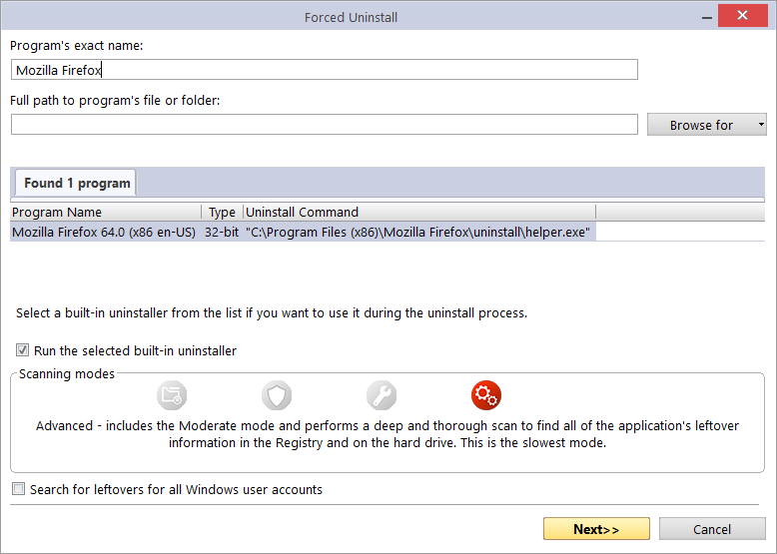

After entering the initial parameters, Forced Uninstall will search for a built-in uninstaller and any trace logs for the program you want to uninstall. Revo Uninstaller Pro searches for logs in the Traced Programs module and the Logs Database. If found, the results are shown in two tabs - Found xx program(s) and Found xx log(s).

Revo Uninstaller Pro will list any built-in uninstaller(s) found in the same window so that, if necessary, you can choose which one to use.

Any log(s) found will be listed together with the following details:
Name - the log name, usually the same name as the program.
Program Version - if from the Logs Database, you will see its version, which can help decide if it is appropriate to use.
Windows Version – the Windows version for which the log was made can also help decide if it is appropriate to use.
Source - where the log was found - in Traced Programs or the Logs Database.

Forced Uninstall offers you 3 mutually exclusive solutions to continue the removal process. Choice will be influenced by what data has been found to this stage.

NOTE: For all 3 choices, Revo Uninstaller Pro will create a full Registry backup (unless disabled in Options) and a System Restore Point (unless disabled in Options).

Option 1 - No Log(s) nor built-in Uninstaller(s) found.

The only choice is to click NEXT to begin the search for leftover data, as fully detailed in the later sections of chapter 3.4 – All Programs module Uninstall.

Option 2 - A built-in Uninstaller is found. (A Log may also be found, but you prefer to use the Uninstaller.)

Check the option Run selected built-in uninstaller, and click Next. When finished, click SCAN to search for leftover items, as fully detailed in the later sections of chapter 3.4 – All Programs module Uninstall.
TIP: The built-in uninstaller may show up behind other open windows. If so, hold the Alt key and press the Tab key to cycle between windows.

Option 3 - A Log is found. (A built-in Uninstaller may also be found, but you prefer to use the Log). As a general guide, we believe use of a found log offers the best opportunity for a clean uninstall.
IMPORTANT: Any found log you use must be at least to the same major version.

Select the log you wish to use, check the Use selected log option and click NEXT. When finished, it will display the selected leftover log data (Registry items first, files & folders second), as fully detailed in the later sections of chapter 3.4 – All Programs module Uninstall.
NOTE: Revo Uninstaller Pro requires an Internet connection to be able to use a traced log from the Logs Database.

IMPORTANT: The above options are mutually exclusive, but you can use one option after another. For example; you ran option 2, but the built-in Uninstaller hung or crashed. You may still have continued to scan and removed some items, but remnants still exist. Don't worry. Now just try option 3.

4.4 - Forced MSI Uninstall

For programs that use MSI (Microsoft Installer), the built-in uninstaller of a program selected for removal will also contain a Change or Repair command, and if they exist, can be seen in the More Commands menu. Executing either command for the program chosen to be removed will open a window and let you either change the installed components of the program, or repair its installation in case it does not work properly.
Sometimes the built-in uninstaller will automatically run one of these commands, even 'though you wish to uninstall the program. Don't worry. First, simply cancel both the programs' built-in uninstaller and Revo Uninstaller Pro’s uninstall wizard. Secondly, re-select the program to be removed, but this time use the Forced MSI Uninstall command that can be found by opening the context menu of the MSI program.
Then follow the procedure in chapter 3.4 – All Programs module Uninstall.

4.5 - Hunter Mode

Many applications load on Windows start-up, or remain in the system tray without your consent. You may not even know which application does what. Hunter Mode is an innovative and flexible tool which lets you uninstall, stop or delete by simply pointing to application icons on the Desktop, in the system tray, or to open application windows.


Clicking the Hunter Mode button in the Tools group in the Commands panel will replace the Revo Uninstaller Pro’s window with a small blue Target icon with a cross-hair. This will appear in the upper right corner of your screen. Hunter Mode is now activated.

Right click the Target icon for a context menu with the following options:
Open main window – exits Hunter mode, and re-opens Revo Uninstaller Pro’s main window.
Auto Start with Windows – sets Hunter Mode to start automatically.
Always on top – if turned on, Hunter Mode’s window stays on the top of all other opened windows. If turned off, the quickest way to view the Hunter Mode is to left click the Revo Uninstaller Pro’s icon in the system tray.
Window's size – allows you to change the size of the target icon.
Transparency – allows you to set the level of transparency of the target icon (default is 50%).
Help – opens Revo Uninstaller Pro’s help file.
EXIT – closes Revo Uninstaller Pro entirely.

To operate, simply drag and drop the Target icon over the icon or window of the program you want to manage.

Here is a more detailed description:
1. Press and hold the left mouse button over the target icon.
2. Drag and hold the Target icon over an item supported by the Hunter mode. A tooltip will display information about the application you would select if you released the button.
3. Now release the left mouse button and a context menu will appear.
4. Select a command:
Uninstall – starts the Forced Uninstall module of Revo Uninstaller Pro.
Stop Auto Starting – disables the application from automatically starting with Windows.
Kill – forcibly stops/closes the application.
Kill and Delete – forcibly stops, and deletes the application.
Open Containing Folder – opens selected program's folder in Windows Explorer.
Search at Google for - search the program’s name or publisher.
Properties - show the application executable file's properties.
Cancel – cancels the operation.

4.6 - Traced Programs Module – Advanced Uninstall

Imagine you are running a Traced Programs module uninstall. See chapter 3.2. It is possible that Revo Uninstaller Pro may find additional data related to the program you are removing, but not delete it because it was not logged during its' INSTALL process.

If this happens, Revo Uninstaller Pro will automatically open an Advanced Uninstall wizard giving you the opportunity to review and delete this additional data.

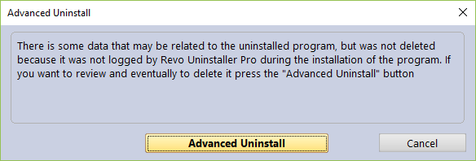

Clicking the Advanced Uninstall button will open a new window and display leftover Registry items first, and then leftover files and folders. Follow the standard removal procedure as detailed in chapter 3.4 - All Programs module Uninstall. But note the caution below.

IMPORTANT: Do not delete any data without being absolutely certain that it is related to or created by the uninstalled program, and so please take additional care in verifying all data. Remember that the “additional data” may not all be related to the uninstalled program. It is quicker to do this, than resort to Backup procedures.

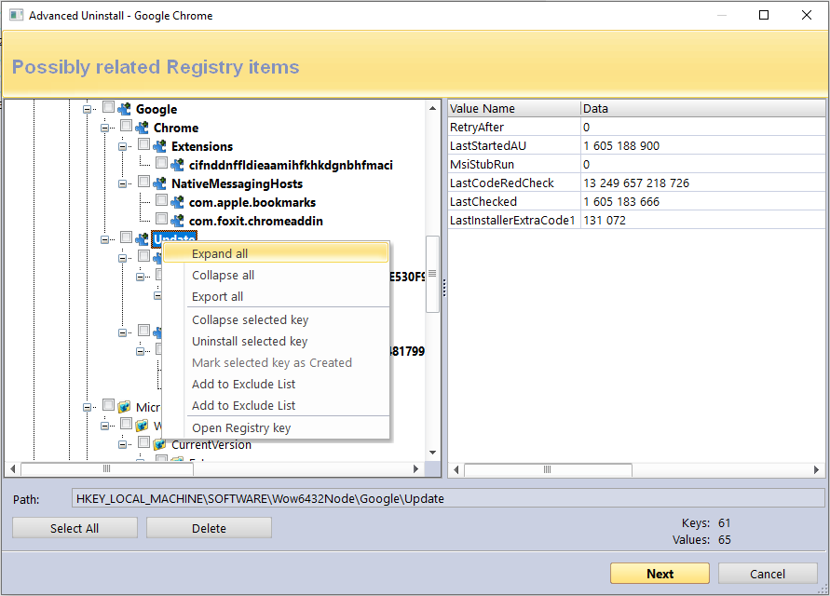

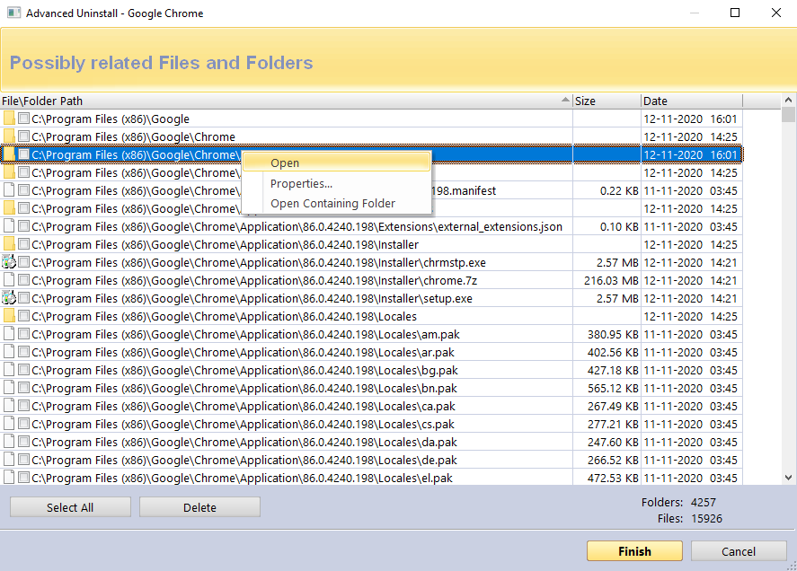

4.7 - Traced Programs Module - Custom Uninstall

Under normal circumstances, you would uninstall a logged program with just a few mouse clicks – see chapter 3.2 - Traced Programs module Uninstall.

However, some users may simply wish to know more about the structure of a specific program. Others may wish to identify and export specific Registry items before conducting an Uninstall task. Still others may wish to uninstall just part of a logged program. For example, imagine you used Revo Uninstaller Pro to install a program, see chapter 3.1 – Traced Programs module – Install, but by mistake you started another program at the same time. You could use Custom Uninstall to “undo” the error. Although it is recommended that you avoid the need for this altogether.

Clicking Custom Uninstall starts the uninstall wizard, but does not automatically complete the Uninstall procedure. Instead, it will display all logged Registry keys and values in a window, with all related files and folders in another, letting you choose which elements, if any, of the chosen program you wish to remove.
The different colored fonts provide information about the leftover items:
Bold item – logged by Revo Uninstaller Pro as created by the installed program.
Red item – the item is excluded from the uninstall process (the list of excluded items is shown in Options -> Uninstaller -> Traced Programs -> the Registry tab).
Grayed item – the item does not exist in the system at the moment.

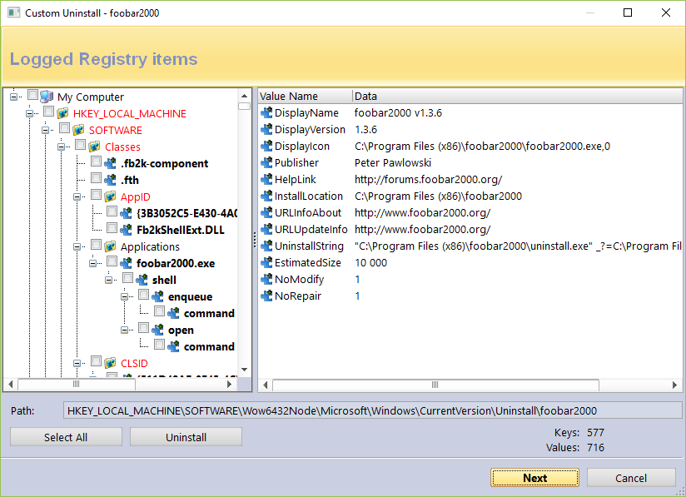

The number of logged keys and values are detailed in the lower part of the window.

IMPORTANT: You have to check items that you want to uninstall.

Follow the standard removal procedure as detailed in chapter 3.4 - All Programs module Uninstall.

Click the Next button to see if there are any logged files and folders. The number of logged files and folders are detailed in the lower part of the window. There is also an option to rename items that had existed with a certain name before the installation of the program, but were renamed during said installation: Execute Rename operations of previously existing on the system files and folders.

Follow the standard removal procedure as detailed in chapter 3.4 - All Programs module Uninstall.

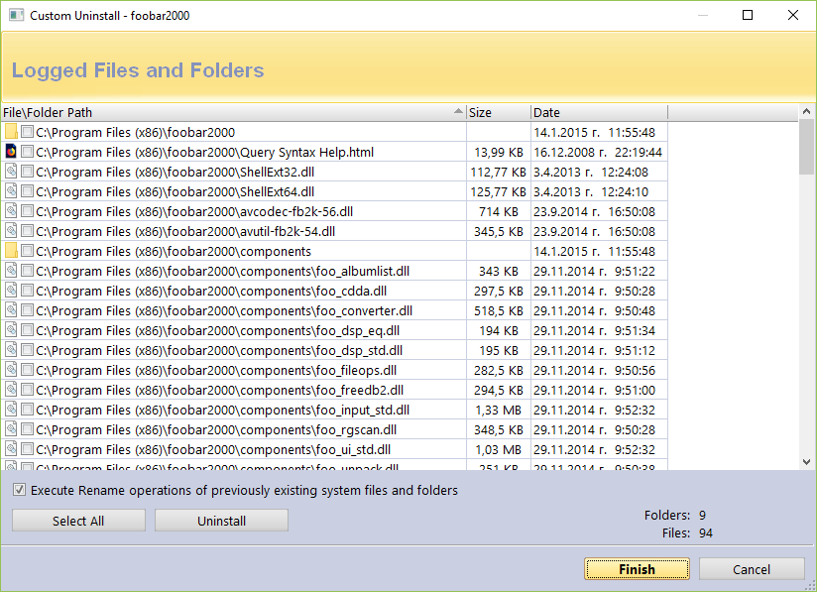

4.8 - How To Restore A Full Registry Backup

Revo Uninstaller Pro can create a full Registry backup once each day it is started. By default, this option is not selected.

A full Registry backup is, by default, created for each program uninstall.

IMPORTANT: Full Registry backups should only be used if Windows Restore/Backup Manager cannot restore removed items, or if Windows no longer starts properly.

NOTE: The procedure to restore a full Registry backup will vary dependent upon the version of your computer's operating system, as follows:

4.8.1 - For Windows Vista and Windows 7

1. - Restart your computer. During reboot, it will generally list peripheral equipment installed on your machine, memory size, the hard drives installed, etc. At this stage, commence rapid, repeated tapping of the F8 key until a Windows Advanced Options menu appears.
NOTE: Some OEM computers can use a different function key to F8, and so refer to the instructions that came with your computer.

2. - Select the Repair Your Computer option.
3. - Follow screen instructions until you see the System Recovery Options window.
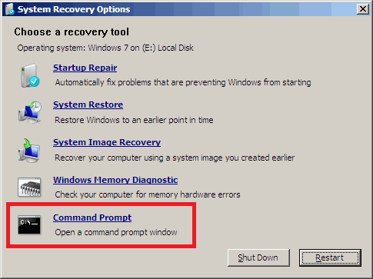
4. - Select Command Prompt to restore a full Registry backup.
Enter (type) each of the following commands (in bold). Press Enter after each step:
(Assuming you have installed Windows on “Local Disk (C :)”)
Step 1: C:
Step 2: CD Users
Step 3: DIR
(A list with folder names will appear, including your user name, remember it for the next step.)
Step 4: CD “XXX\AppData\Local\VS Revo Group\Revo Uninstaller Pro\RegBackup\Daily\”

OR

Step 4: CD “XXX\AppData\Local\VS Revo Group\Revo Uninstaller Pro\RegBackup\Last\”
(Replace XXX with your user name found in step 3. Ensure you include the quotation marks above.)
There may be two folders with a full Registry Backup. The first folder is named Daily because it is created once a day. The second folder is created for each program uninstall. If you are sure you want to restore a full Registry backup created before a program uninstall, use the second option for Step 4 – Last.
Step 5: ren Restore.dat Restore.bat
Step 6: Restore.bat

4.8.2 - For Windows 8 and Windows 10

You need to start the computer in an unusual way to find the Command Prompt option.

Begin by pressing and holding the Shift key and only then may you reboot your computer as normal. Continue to hold the key down until the computer fully restarts and you see the Choose an Option screen.

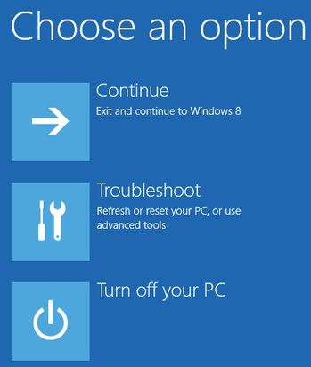

Now proceed as follows:
1 - Click the Troubleshoot button.
2 - Click the Advanced Options button.
3 - Click the Command Prompt button.
4 - Log into your account, and you will see the Command Prompt window.
Enter (type) each of the following commands (in bold). Press Enter after each step:
(Assuming you have installed Windows on “Local Disk (C :)”)
Step 1: C: Step 2: CD Users
Step 3: DIR
(A list with folder names will appear, including your user name, remember it for the next step.)
Step 4: CD “XXX\AppData\Local\VS Revo Group\Revo Uninstaller Pro\RegBackup\Daily\”
OR
Step 4: CD “XXX\AppData\Local\VS Revo Group\Revo Uninstaller Pro\RegBackup\Last\”
(Replace XXX with your user name found in step 3. Ensure you include the quotation marks above.)
There may be two folders with a full Registry Backup. The first folder is named Daily because it is created once a day. The second folder is created for each program uninstall. If you are sure you want to restore a full Registry backup created before a program uninstall, use the second option for Step 4 – Last.
Step 5: ren Restore.dat Restore.bat
Step 6: Restore.bat

4.9 - Command Line support

Revo Uninstaller Pro supports command line options and has a command processor: RevoCmd.exe.

RevoCmd.exe can be used to list installed programs on a computer. It can be used to list programs by a part of their name, and it can also show the installation location and the uninstall command of a program, which can be then used to start its built-in uninstaller.

Usage:
RevoCmd /m "program name" [/i] [/u] [/p]
/m - match program name using wildcard characters - * and ?
The asterisk (*) wildcard represents any combination of characters.
The question mark (?) wildcard represents any single character.
Example: RevoCmd /m Microso*
Shows all programs beginning with Microso
/i - include installation location, if it exists
/u - include uninstallation command
/p - pause on each page
/? or /help - this help

Some Revo Uninstaller Pro operations can be executed from a command line. Supported command line operations and their arguments are:

Regular Uninstall - you can uninstall programs listed in Revo Uninstaller Pro. The uninstall process does not start the built-in uninstaller of the selected program. It will, instead, automatically delete Registry entries, files, and folders found as leftovers and created by the program.

Syntax:
RevoUninPro /mu "Program name" /path "Full program path" /mode "uninstall mode" /32

Where the parameters are:
/mu - exact name of the program, as it is listed in Revo Uninstaller Pro.
/path - full path to the program's installation folder. The path must not end with a backslash character (\).
/mode - mode of the uninstallation - Safe, Moderate, or Advanced.
/32 or /64 - depending if the program is 32-bit or 64-bit.

Example:
RevoUninPro /mu "Yahoo Toolbar" /path "C:\Program Files\Yahoo Toolbar" /mode Moderate /32

Traced Uninstall - you can uninstall a traced program using the name of its trace log. The uninstall process reverts all logged system changes.

Syntax:
RevoUninPro /tu "Log name"

Where the parameters are:
/tu - exact name of the log file, as you have saved it after tracing the program’s installation, i.e. as it is listed in Revo Uninstaller Pro.

Example:
RevoUninPro /tu "Yahoo Toolbar"

Export - you can export lists of all installed programs, and all traced programs. All details/properties are included in the exported files.

Syntax:
RevoUninPro /export "Full export path" /all /traced /txt /xls /html

Where the parameters are:
/export - full path to the export file, and where the exported information will be stored.
/all - export the “All Programs” list.
/traced - export the “Traced Programs” list.
/txt - export the information in a text file (.txt).
/html - export the information in an HTML file (.html).
/xls - export the information in a Microsoft Excel spreadsheet (.xls).

NOTE: To export installed programs to a Microsoft Excel spreadsheet you must have Microsoft Excel installed and correctly working.

Example:
RevoUninPro /export "C:\My data\allprograms.txt" /all /txt

Windows App Uninstall - you can uninstall one or more Windows Apps listed in Revo Uninstaller Pro. The uninstall process starts the built-in uninstall procedure of the selected App, then automatically scans for and deletes Registry entries, files, and folders found as leftovers.

Syntax:
RevoUninPro /wa "App1;App2"

Where the parameter is:
/wa - exact name of the App(s), as listed in Revo Uninstaller Pro, separated by a semicolon (“;”) if more than one.

Example:
RevoUninPro /wa "TikTok;Lively Wallpaper"

Browser Extension Uninstall - you can remove one or more browser extensions listed in Revo Uninstaller Pro.

Syntax:
RevoUninPro /be "BrowserExt1;BrowserExt2" /ie /edge /chrome /firefox /opera "ProfileName"

Where the parameters are:
/be - exact name of the browser extension(s), as listed in Revo Uninstaller Pro, separated by a semicolon (“;”) if more than one.
/ie /edge /chrome /firefox /opera – the browser, to which the extension(s) belong(s). “ProfileName” – the name of the profile, under which the extension(s) is/are installed; if no profile name is entered, the default one is used.

Example:
RevoUninPro /be "Tab Mix;BuiltWith" /firefox “Tester”

Update Revo Uninstaller Pro – you can initiate a silent update of Revo Uninstaller Pro.

Syntax:
RevoUninPro /update /silent

Hunter Mode - you can start Revo Uninstaller Pro in Hunter Mode.

Syntax:
RevoUninPro /hunter

4.10 - Keyboard Shortcuts

TABLE SHOWING ALL KEYBOARD SHORTCUTS

COMMAND | HOTKEY
Options | Alt+O
Hunter Mode | Alt+H
Exit | Alt+X
ALL PROGRAMS | Alt+U
Uninstall | Ctrl+U
Quick Uninstall | Ctrl+Q
Refresh | Ctrl+R
Forced Uninstall | Ctrl+F
Install Programs | Ctrl+L
Print | Ctrl+P
Print Preview | Shift+P
Print Setup | Ctrl+Shift+P
TRACED PROGRAMS | Alt+T
Uninstall | Ctrl+U
Custom Uninstall | Ctrl+C
Refresh | Ctrl+R
Edit Log | Ctrl+D
Install Programs | Ctrl+L
Import Log | Ctrl+I
Export Log | Ctrl+E
Print | Ctrl+P
Print Preview | Shift+P
Print Setup | Ctrl+Shift+P
WINDOWS APPS | Alt+W
Uninstall | Ctrl+U
Refresh | Ctrl+R
BROWSER EXTENSIONS | Alt+R
Uninstall | Ctrl+U
Refresh | Ctrl+R
LOGS DATABASE | Alt+L
Uninstall | Ctrl+U
Custom Uninstall | Ctrl+C
AUTORUN MANAGER | Alt+A
Run | Ctrl+N
Kill | Ctrl+K
Add | Ctrl+A
Remove | Ctrl+M
Disable | Ctrl+D
Refresh | Ctrl+R
JUNK FILES CLEANER | Alt+J
Scan | Ctrl+S
Delete | Ctrl+D
WINDOWS TOOLS | Alt+T
Run | Ctrl+R
HISTORY CLEANER | Alt+C
Clear | Ctrl+C
Clear All | Ctrl+A
EVIDENCE REMOVER | Alt+E
Execute | Ctrl+E
UNRECOVERABLE DELETE | Alt+D
Delete Forever | Ctrl+D
Add File(s) | Ctrl+F
Add Folder | Ctrl+Shift+F
Backup Manager | Alt+B

5 - TOOLS

Revo Uninstaller Pro includes eight powerful tools to clean and maintain your system. Access them by clicking the Tools button in the GUI Commands Panel.

5.1 Autorun Manager - 5.2 – Junk Files Cleaner - 5.3 Evidence Remover 5.4 Unrecoverable Delete - 5.5 History Cleaner (includes 3 other tools) 5.6 Windows Tools

Many useful tools and components are bundled with every Windows operating system. Some have complex command line options whilst others are difficult to access. The Windows Tools section 6.6 in Revo Uninstaller Pro gives you a fast – one-click access to a maximum nineteen Windows tools, which you can use in your daily routine. Some tools are dependent upon the version of Windows you are running.

5.1 - Autorun Manager

A brand new Windows computer has relatively few applications set to auto start when first switched on. As you install new software, some will self-set to start with your computer. System programs, antivirus software, and firewalls must be run at Windows startup to keep your system running smoothly, but most others rarely need to start automatically. Just look at all the icons in your system tray. When an application is started, it consumes memory (RAM) and CPU time. This impacts upon your computer's performance.

Revo Uninstaller Pro's Autorun Manager gives you control over which processes, services, and scheduled tasks can start with Windows. It lets you search for details about your auto-starting programs including publisher, description, launch path, and whether the process is currently running. You can also directly access Google with just 2 clicks, all designed to help decide whether to enable or disable the process.

Right click on a column header to show or hide any of them before you print details.
Use the Search field in the upper part of the Commands Panel to filter the programs list by name, launch path, or publisher. The program list will be filtered in real-time as you type. When searching, the status bar will display the number of found programs that match the search criteria.

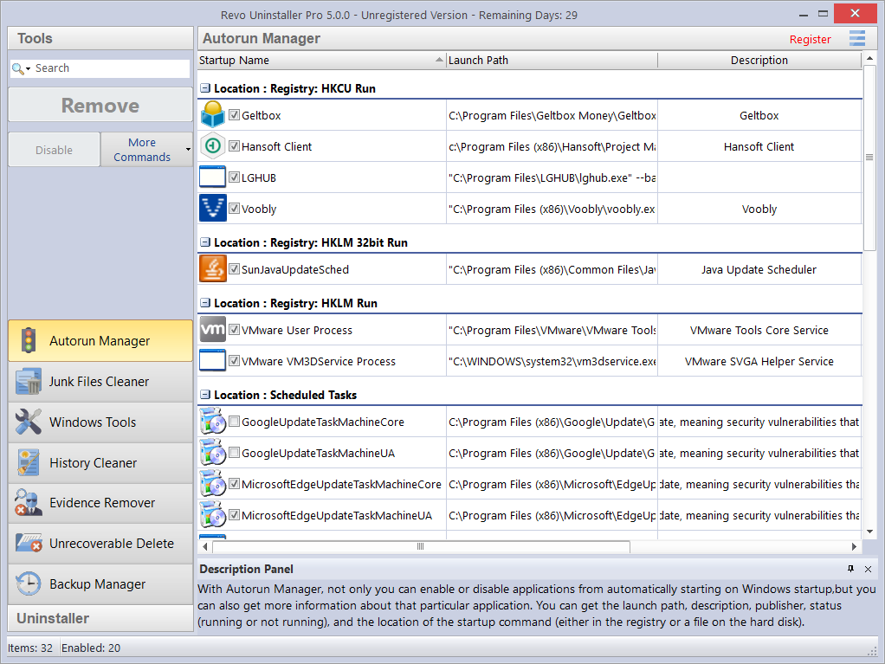

The most common task will be to Enable or Disable an application from auto starting. Simply check or uncheck the box in front of the application name. Job done.

The alternative is to Remove a program. This will both disable and remove it from the list.
NOTE: It is recommended to simply Disable a program and watch for unwanted consequences before deleting. The process is easily reversed (just check the box again). Remove a program only if you are certain it will not have a negative impact.

Click More commands to access additional options.

Run process – starts the selected program or process if it is not RUNNING.
Kill process – forcibly stops a program if it is RUNNING.
Export List to – lets you export the Autorun list to TXT, HTML, or XLS (Microsoft Excel spreadsheet). You can choose which details/columns to include.
NOTE: To export an XLS file, you must have Microsoft Excel installed and correctly working.
Print – lets you print the Autorun list.
Add – lets you manually add a program for automatic startup.
Name – the name of the program which will appear in the Autorun Manager.

Command (full path) – full path to the program you want to automatically run. You can also add parameters for the executable, but if you do so, put the path in quotations marks. For example:
“C:\Program Files\VS Revo Group\Revo Uninstaller Pro\RevoUninPro.exe” /hunter

Set auto start for:
All users – if you want the program to start when any user logs in.
Current user – if you want the program to start when only the current user logs in.
Select to auto-start from:
Registry: Run – on every startup of Windows – this option will add a startup entry to the Windows Registry, which is a very common location for automatic startups.
Registry: RunOnce – only once on the next startup of Windows – also adds a startup entry in the Windows Registry, but it will start the program only once, after which the startup value in the Registry is automatically deleted by Windows.
Startup Folder – on every startup of Windows – this option will add a shortcut to the program in the Startup folder, which is also a very common location for startups.
NOTE: It is accessible from Windows Explorer: C:\Users\[YOURPROFILE] \AppData\Roaming\Microsoft\Windows\Start Menu\Programs\Startup\.
NOTE: The AppData folder is hidden so you may need to display the hidden files and folders.
Refresh – reload the Autorun list.

Additionally, you can right click to bring up a context menu for any Autorun item. These are the available commands:
Run Process - starts the selected program or process if it is not RUNNING.
Kill Process - forcibly stops a program if it is RUNNING.
Search at Google for – used to search online for the Autorun item’s name, file name, publisher, or description. Selecting this will open your default web browser and display the results of the search.
Open containing folder - opens the folder containing the selected Autorun item in Windows Explorer.
Goto Location – opens the location of the Autorun item, which can be a Registry entry, a shortcut in the Startup folder, etc.
Copy Launch Path – copies the launch path to the Windows clipboard so you can paste it into a text file, e-mail, chat message, etc.
Remove selected – removes the selected Autorun item; the same as selecting it, and clicking the Remove button, as explained earlier.
Remove all invalid – removes all Autorun items that are detected as invalid, i.e. there is an Autorun entry but it does not point to an existing process or program.
Remove all disabled – remove all Autorun items that are currently disabled (unchecked).
Properties – shows the file’s properties in Windows Explorer.
Open Windows Services – starts the Windows Services manager (services.msc) for more in-depth control over the services.

5.2 - Junk Files Cleaner

Many Windows applications create junk files. Such files are normally deleted as soon as they become unnecessary, by the application that created them. However, they can remain on your hard drive if the program that created them was terminated unexpectedly or if it was not programmed to delete said files, or if there was a system crash, etc. Accumulation of junk files takes up disk space, and may also impact on system performance.

Junk Files Cleaner lets you find and remove unnecessary files from your computer.
You can select which drives to scan, and what type of file extension to scan for. The most common temporary and junk files extensions are built-in, but you can also add whatever extensions you wish. You can manually add a specific folder (Options -> Junk Files Cleaner -> Include), whose content will then be considered junk and will be removed at every scan.

If you do not want to scan a whole drive, just select a specific folder. To do so, use the Scan Folder... button/text, just above the list of drives. As soon as you select a folder, the scanning will begin.

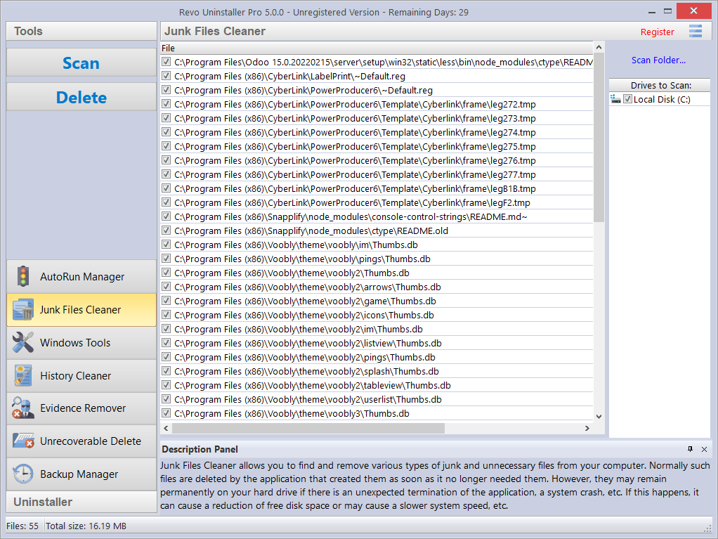

Available commands for Junk Files Cleaner:

Scan –performs a scan with your current settings. A small window will appear while the scanning is in progress. Cancel the scan by clicking the Cancel button. You will be presented with a list of files found up to that point.
Delete – deletes all found junk files that have a check-mark, after the scan is completed or canceled.

Right click a junk file to access a context menu with the following options:

Open – opens the selected file, just as if you have double clicked it.
Search at Google for – use it to search online for the name of the selected file. This will open your default web browser and display the results of the search.
Open containing folder - opens the folder containing the selected item in Windows Explorer.
Properties – shows the file’s properties in Windows Explorer.
Check all items – adds a check-mark for all files in the list.
Uncheck all items –removes check-marks for all files in the list.
Check all selected items - adds a check-mark for all selected files in the list.
Uncheck all selected items - removes check-marks for all selected files in the list.

5.3 - Evidence Remover

Deleting files and folders from the Recycle Bin does not mean that they are gone forever. They are simply marked as deleted but not physically erased. Your “deleted” data may be confidential, but can still be easily retrieved using standard recovery tools or un-delete programs – even many years later.

Evidence Remover will eliminate any possibility of data retrieval from your hard drive(s). It will permanently erase previously “deleted” files and folders still left physically on your hard disk. No matter what recovery tool (free, professional, expensive, whatever) may be subsequently employed, the result will always be the same - data erased with Evidence Remover is impossible to recover.

To erase previously deleted files and folders, simply check the drive from which those files were deleted, then click the Execute button in the Commands Panel. Once started, you will see a window with a progress bar and the estimated time remaining for the operation. You have the option to Pause/Resume the process.

The process can be slow, because the data is randomly overwritten three times. The overall speed depends upon:
- your computer’s processor (CPU);
- the size of the selected drive;
- any running programs;
- any running security software – antivirus, Internet Security, etc.

Free disk space will reduce during the process because Evidence Remover creates a huge file into which random data is written. This file is deleted at the end of the process when free disk space is restored.

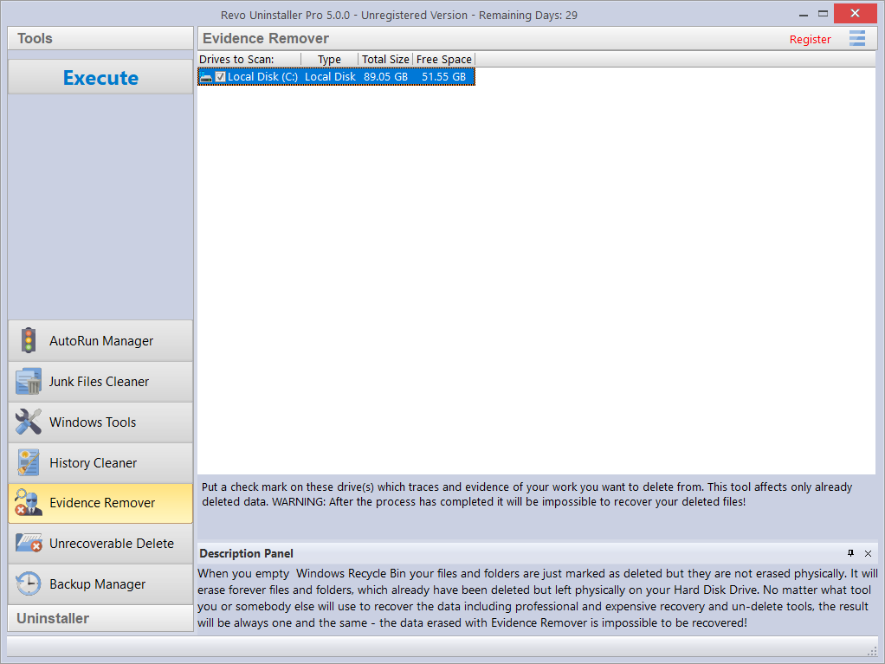

5.4 - Unrecoverable Delete

As detailed in chapter 5.3 Evidence Remover, simply deleting files and emptying the Recycle Bin does not mean they are gone forever.

Deleting files in Windows just means that they are marked as such, and the space allocated to them up until that point then becomes available for other use. This is because if Windows had to physically erase all deleted files, it would take a long time and slow down your computer. There are also many system, temporary, and other files which are unimportant so making them unrecoverable would be waste of resources. Unrecoverable Delete physically only erases those files and folders that you select, but will take longer than a simple Windows delete.

So to securely delete your selected files and folders and be sure that no one, with any recovery tool (free, professional, expensive, whatever) will retrieve them, use Unrecoverable Delete. The result will always be the same – the erased data is impossible to recover.

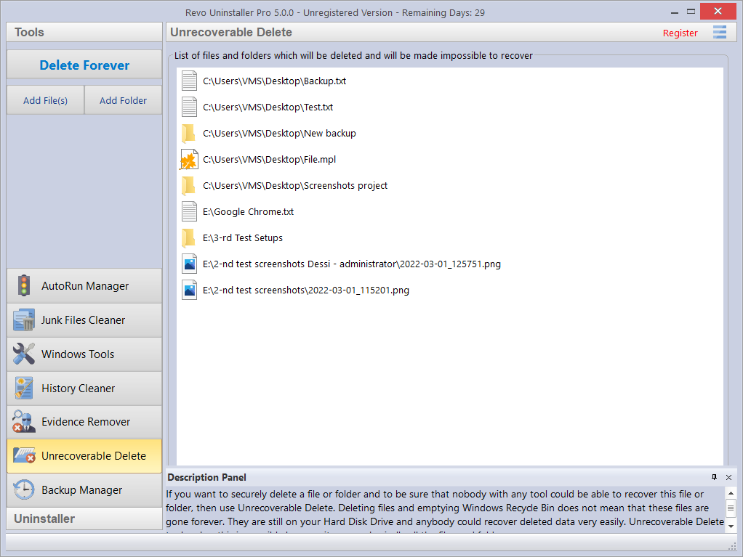

Unrecoverable Delete has the following commands:
Add File(s) – use it to add a file(s) that you want to erase forever.
Add Folder – use it to add a folder that you want to erase forever. All files and sub-folders of the selected folder will be erased.
Delete Forever – starts the erase process. Once started, you will see a window with a progress bar and the estimated time remaining for the operation. You have the option to Pause/Resume the process.

IMPORTANT: You can cancel the process but the files erased before cancellation will be unrecoverable, so please be careful when selecting the files and folders you want to erase.

NOTE: The window of the Unrecoverable Delete tool supports drag and drop of files and folders. Revo Uninstaller has administrative privileges and so programs with lower privileges cannot use the drag and drop function. You must, therefore, run Windows explorer or any other file manager as an administrator (and not as a standard user), or you will be unable to drag and drop files into Unrecoverable Delete.

5.5 - History Cleaner

The History Cleaner tool consists of three modules – Browsers Cleaner, Windows Cleaner, and Microsoft Office Cleaner. Each is accessible from a tab at the top of the main window of History Cleaner. Use the Clear button when a specific cleaner is active, or the Clear All button for all 3 cleaners combined.

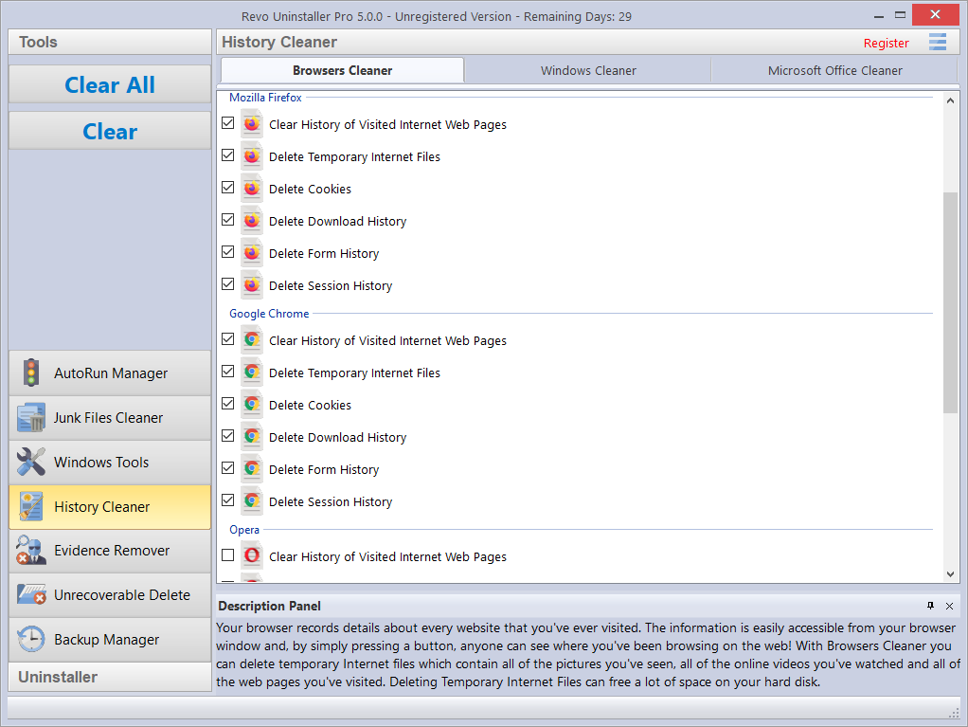

Browsers Cleaner - Your browser makes a detailed record of every web site you visit. A simple press of a button in your browser window lets anyone see what you have been browsing on the web. Temporary internet files include images, videos, audio files, etc., plus all the web pages you have visited. Browsers Cleaner erases web site history for the following browsers: Edge, Internet Explorer, Firefox, Google Chrome, and Opera. Deleting this history will also free up space on your hard disk.

Check the desired options for the browser history you want to clean and then click the Clear or Clear All buttons in the Commands Panel. You can also check or uncheck all options for one or all browsers by right clicking, and selecting the appropriate setting.

Windows Cleaner - Microsoft Windows keeps a history of the many things you do - see the options listed below. Windows Cleaner lets you remove this history easily and quickly. You can also empty your Recycle Bin, and delete temporary files, freeing up more disk space.

Available options for Windows Cleaner are:
  - Clear Recent Documents History
  - Clear Start Menu Run History
  - Clear Find File History
  - Clear Printers, Computers and People Find History
  - Empty Clipboard
  - Clear “MS Paint” Recent Files History
  - Clear “MS WordPad” Recent Files History
  - Clear “Regedit” Last Opened Key History
  - Clear Common Dialog Open Save Recent History
  - Clear Common Dialog Last Visited Folder History
  - Empty Recycle Bin
  - Delete Windows Temporary Files
  - Delete Start Menu Click Logs
  - Delete crash memory dump files
  - Delete Chkdsk (Check Disk) recovered file fragments
  - Delete Thumbnail Cache.

Check the desired options you want to clean and then click the Clear or Clear All buttons in the Commands Panel. You can also check or uncheck all options by right clicking and selecting the appropriate setting.

Microsoft Office Cleaner - lets you remove history of the most recently used files in Microsoft Word, Excel, Access, and PowerPoint. If you do not wish anyone else to see your last opened or edited documents, spreadsheets, or any other files created using Microsoft Office, simply check them, and then click the Clear or Clear All button in the Commands Panel. Your most recently used files will no longer be listed. You can also quickly check or uncheck all options by right clicking, and selecting the appropriate setting.

NOTE: Remember, the Clear All button will cleanse all 3 history modules in one go.

5.6 - Windows Tools

Many useful tools and components are bundled with every Windows operating system. Some have complex command line options whilst others are difficult to access. Windows Tools gives you a fast – one-click access to a maximum nineteen Windows tools, which you can use in your daily routine.
Also, you are easily able to add your own tool here using the Add button. You can edit a custom tool by selecting it, and clicking the Edit button, and you can delete it by right clicking it, and selecting Delete.

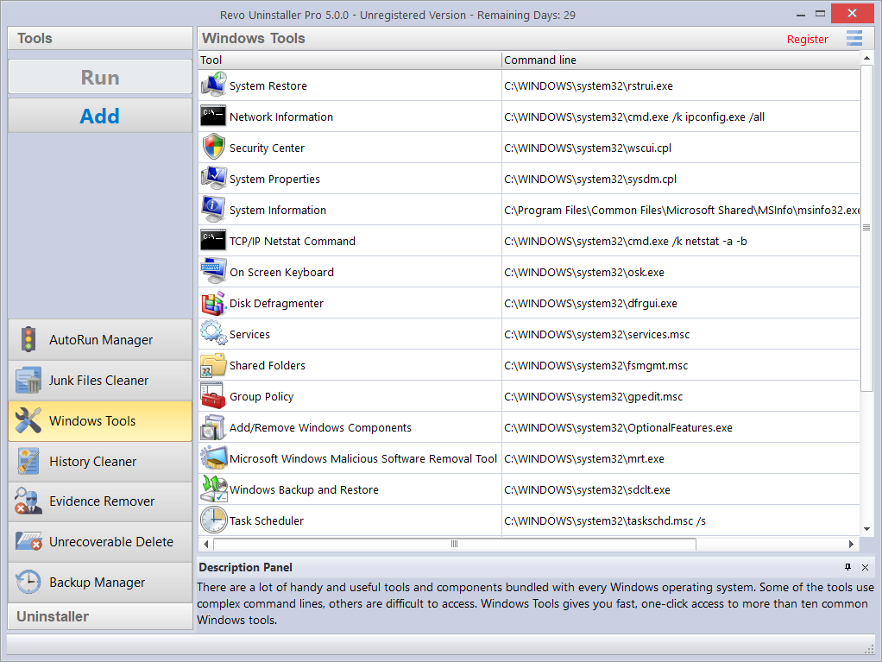

NOTE: Tools are available for 32 bit & 64 bit versions of Windows Vista, 7, 8 (Pro), 8.1, 10,11 and 64 bit Server 2012 R2. Exceptions are:

Windows Vista, 7, 8, 8.1 – Deployment Image Servicing and Management (DISM) (unavailable)
Windows 8 (Pro) x86 – Malicious Software Removal Tool (unavailable)
Windows 8.1 x86 - Malicious Software Removal Tool (unavailable)
Windows 8.1 x64 – Group Policy only available for the Pro version
Windows Server 2012 R2 x64 – System Restore; Security Center; Add/Remove Windows Components; Windows Backup and Restore: (all unavailable)

5.6.1 - System Restore

System Restore lets you revert your computer to a previous state if a problem occurs, without losing any personal data files (including documents, images, videos, music, browsing history, drawings, favorites, e-mails, etc.).

System Restore creates snapshots of the most vital areas of the system, called Restore Points. They are created both daily and when significant system events occur (for example: when a program or driver is installed, when Windows updates are installed, etc.). You can also create Restore Points manually.

NOTE: By default, Revo Uninstaller Pro creates a Windows Restore Point at the start of any uninstall operation (before deleting any data).

5.6.2 - Network Information

Network Information is used to display all current TCP/IP network configuration values, refresh Dynamic Host Configuration Protocol (DHCP) and Domain Name System (DNS) settings, Displays the full TCP/IP configuration for all adapters including IP address, MAC address, subnet mask, default gateway, Windows Internet Naming Service (WINS) and DNS configuration. Adapters can represent physical interfaces, such as installed network adapters, or logical interfaces, such as dial-up connections.

5.6.3 - Security Center

Security Center is used to check the security status of your computer’s firewall, virus protection software, and automatic Windows updates. If a problem is detected (for example; if your antivirus program is out of date), the Security Center both alerts you and provides recommendations on how to better protect your computer.

5.6.4 - System Properties

System Properties lets you:
- View basic information such as your CPU and amount of memory (RAM).
- View and change settings that control how your computer uses memory and finds certain information.
- Find information about hardware and device properties, as well as configure hardware profiles.
- View information about your network connection and logon profile.
- Report system and program errors to Microsoft or your system administrator when they occur.

5.6.5 - System Information

System Information collects and displays system configuration information for local and remote computers. This includes information about hardware configurations, computer components, and software, including signed and unsigned drivers.

5.6.6 - TCP/IP Netstat Command

The TCP/IP Netstat Command displays all active TCP connections and the TCP and UDP ports, on which the computer is listening, and displays the executables involved in creating each connection or listening port. In this case, the executable name is in [ ] at the bottom, on top is the component it called, and so forth until TCP/IP was reached. In other words, this command shows which applications are using which port to connect to the Internet, and which applications are listening for incoming connections.

5.6.7 - On-Screen Keyboard

On-Screen Keyboard is a virtual keyboard allowing mobility impaired users to type data using a pointing device or joystick. You can also use On-Screen Keyboard if you believe you have a keylogger installed on your computer, and that the keys you type are being recorded (eliminating the possibility of recording typed keys). It can also be used as a temporary/emergency workaround should you have a problem with your real keyboard.

5.6.8 - Disk Defragmenter

Disk Defragmenter analyzes local volumes and consolidates fragmented files and folders so that each occupies a single, contiguous space in the volume. As a result, your system can access files and folders and save new ones more efficiently. By consolidating your files and folders, Disk Defragmenter also consolidates a volume's free space, making it less likely that new files will be fragmented. The process of consolidating fragmented files and folders is called defragmentation. After defragmentation, your hard disk drive will be well arranged and your system will work faster.

5.6.9 - Services

A service is an application type that runs in the background. Services typically provide features such as client/server applications, Web servers, database servers, and other server-based applications to users, both locally and across a network. You can use the Services component to:
- Start, stop, pause, resume, or disable a service on remote and local computers. You must have the appropriate permissions.
- Manage services on local and remote computers.
- Set up recovery actions to take place if a service fails; for example, restarting the service automatically or restarting the computer.
- Enable or disable services for a particular hardware profile.
- View the status and description of each service.

5.6.10 - Shared Folders

Shared Folders is used to manage shared resources over a network, control user access permissions, session activity, shared resource properties, and to view a summary of connections and resources, uses for local and remote computers. With Shared Folders, you can:
- Create, view, and set permissions for shared resources.
- View a list of all users connected over a network to the computer, and disconnect one or all of them.
- View a list of files that have been opened by remote users, and close one or all of the open files.

5.6.11 - Group Policy

Group Policy is a component that includes policy settings for user configurations which affect users, and for computer configurations which affect computers (all users). Group Policy settings define the various components of the user's desktop environment that a system administrator needs to manage, for example, the programs that are available to users, the programs that appear on the user's desktop, and options for the Start menu. To create a specific desktop configuration for a particular group of users, use the Group Policy snap-in.

5.6.12 - Add/Remove Windows Components

Add/Remove Windows Components (also known as Windows Feature) helps you manage installed Windows components on your computer. After Windows is installed, you can use the Add/Remove Windows Components (Windows Features) to add a Windows component that was not included in the original installation, or to remove an existing Windows component that you no longer require.

5.6.13 - Microsoft Windows Malicious Software Removal Tool

The Microsoft Windows Malicious Software Removal Tool checks your computer for infections by specific, prevalent malicious software, and helps remove any infections found. This malicious software includes viruses, worms, and Trojan horses. When the detection and removal process is complete, the tool displays a report describing the results, including whether any malicious software was detected and removed.

5.6.14 - Windows Backup and Restore

Windows Backup and Restore lets you make backup copies of personal data files for all users of the computer. You can let Windows choose what to back up or you can select the individual folders, libraries, and drives you want to back up.

It also lets you create a system image which includes Windows and your system settings, programs, and files. You can use a system image to restore the contents of your computer should your hard drive or computer ever stop working.

5.6.15 - Task Scheduler

Task Scheduler helps you schedule automated tasks that perform actions at a specific time, or when a certain event occurs. It provides the ability to schedule the launch of programs or scripts at pre-defined times, or after specified time intervals. Task Scheduler maintains a library of all scheduled tasks, providing an organized view of the tasks and a convenient way to manage them.

5.6.16 - Check Disk

Check Disk opens a command prompt window to execute the chkdsk.exe Windows command. Check Disk verifies the logical integrity of the file system on the Windows volume. Check Disk checks for problems related to bad sectors, lost clusters, cross-linked files, and directory errors. These types of problems can be caused by system crashes or freezes, power glitches, incorrectly turning off a computer, etc.

5.6.17 - System File Checker

System File Checker allows you to scan for and restore corruptions in Windows system files, verifying their versions. If it finds a problem, it will attempt to replace the problematic files from the Windows DLL Cache. If the file is not in the Windows DLL Cache or the DLL Cache is corrupted, you may be prompted to insert the Windows installation disk.

5.6.18 - Disk Cleanup

Disk Cleanup is a computer maintenance utility designed to free up disk space on your computer hard drive. It allows users to removes files that are no longer needed or that can be safely deleted like temporary, cache, and log files created by the operating system and other programs.

5.6.19 - Resource Monitor

Resource Monitor displays information about the use of hardware (CPU, memory, disk, and network) and software (file handles and modules) resources in real time. This tool helps you find out how much of your resources are being used at the time of checking, or used over time, through a graphical representation. In this way, you can check the performance counters of specific resources and decide a course of action to improve the performance of the computer.

5.6.20 - Deployment Image Servicing and Management (DISM)

DISM is a command-line tool, as implemented in Revo Uninstaller Pro’s Windows Tools, performs a general scan for corruption, and attempts repairs of common issues it finds within the system image of the operating system.

5.6.21 - Flush DNS cache

The flush DNS cache command may help if you are having trouble accessing a web page or using an online service, as it is possible be that your device has cached an out of date DNS record that needs to be manually cleared or reset.

5.6.22 - DirectX info and diagnostic

The DirectX Diagnostic Tool displays a wealth of information about DirectX, and also lets you perform basic diagnostic tests on the DirectX system. It is used to collect information about devices to help troubleshoot with DirectX sound and video related problems.

6 - MENU/OPTIONS
To view all Revo Uninstaller Pro’s Options, click the Menu button in the top right corner, and select Options.

Remaining menu items are self explanatory.

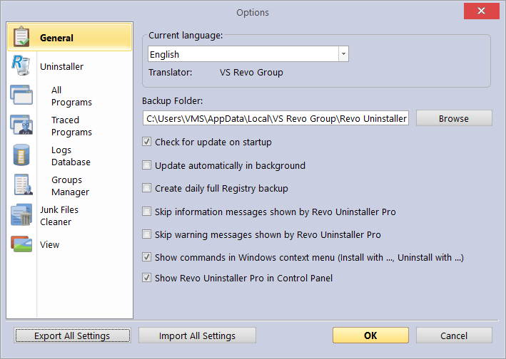

6.1 - General

Provides general options for Revo Uninstaller Pro:

- Current Language: – drop down menu with all available languages for Revo Uninstaller Pro.
Note: if you had selected a specific language at the beginning of Revo Uninstaller Pro’s installation, it will be automatically selected here.
- Backup Folder: – where all backups are stored. You can change it if the currently used drive has little or no more free space.
- Check for update on startup – checks whether a new version is available, by connecting to www.revouninstaller.com on startup, but only once per day. No personal information is sent.
Note: you must allow Revo Uninstaller Pro to connect to the Internet in your firewall.
- Update automatically in background – enables automatic download and update of Revo Uninstaller Pro. You will be notified on the next startup of the program if such updated had occurred.
- Create daily full Registry backup – enables a full Registry backup once each day it is started.
- Skip information messages shown by Revo Uninstaller Pro – enable this option if you do not want to receive information messages. For example: “Revo Uninstaller Pro finished scanning for leftovers”.
- Skip warning messages shown by Revo Uninstaller Pro – enable this option if you do not want to receive warning messages. For example: “Are you sure you want to remove selected item?”
- Show commands in Windows context menu (Install with ..., Uninstall with...) – adds the following commands to the Windows context menu (right click on a file or folder):
- Install with Revo Uninstaller Pro;
- Uninstall with Revo Uninstaller Pro (for folders only).
Uncheck this option to remove these commands in the context menu. A system restart is required for the change to take effect.
- Show Revo Uninstaller Pro in Control Panel – enable this option if you want to place a Revo Uninstaller Pro icon in your Control Panel, acting as a shortcut to launch the program.

6.2 - Uninstaller (General)

Provides general options affecting the whole uninstaller:

- Set focus on Traced Programs on startup – when Revo Uninstaller Pro is started, the All Programs is shown by default; by enabling this option, Traced Programs will be shown instead.
- Make a System Restore Point before uninstall – if Windows System Restore is enabled, Revo Uninstaller Pro sends a request to create a System Restore Point.
- Create a full Registry backup before uninstall – if enabled, creates a full Registry backup which can be used to restore from via the Windows Recovery Console.
- Backup deleted Registry items – this option will cause all changes to the Windows Registry to be backed up. The backups can be restored from Backup Manager.
- Show check boxes in Details view – if enabled, modules that have Details view (All Programs, Traced Programs, Windows Apps, Browser Extensions) and it is used, Revo Uninstaller Pro will display a check box for each entry for easier selection of multiple items.
- Forcibly stop running executable files during their uninstall – if enabled, and Revo Uninstaller Pro is trying to uninstall an executable file(s), then it will try to forcibly stop that file(s). This will prevent some running files from remaining on the system until the next restart (or even after that).
- Delete files and folders –
- to Backup folder - all deleted files are backed up to Revo Uninstaller Pro’s own backup folder. This option is the most secure because you will always have a complete backup, but can require significant hard drive space if the deleted leftovers files are many and/or large.
- to Recycle Bin – This is the default option and moves all deleted leftovers to the Recycle Bin. These can be easily restored until you empty the Recycle Bin after which dedicated recovery software is required.
- Permanently – selecting this option deletes all leftover files and folders permanently. Dedicated recovery software is required to recover them.
- Show as new programs installed – (in the “New Programs” section of All Programs)
- Last (in days) – choose how many days a program is considered as new.
- Since the last startup of the uninstaller – a program is only once shown as new – the first time Revo Uninstaller Pro is run after the program’s installation.

6.3 - All Programs

6.3.1 – All Programs (General)

- Show system updates – enables the listing of Windows updates;
- Show system components – some programs have additional components, which are removable but marked as a component of another program, and by default, Revo Uninstaller Pro does not list them.
- Use program's uninstall data to get the Install Date property - if enabled, Revo Uninstaller Pro reads the installation dates of programs from their own uninstall data in their uninstall Registry key. If not, Revo Uninstaller Pro reads the installation date from the Registry in its own proprietary way.
- Only run the built-in uninstaller – disables scanning when uninstalling a program.
- Search for an appropriate log before program's regular uninstall - if enabled, Revo Uninstaller Pro will search for an appropriate log among your logs and the Logs Database, in order to obtain a more complete program uninstall.
- Open the Uninstall wizard maximized – if enabled, will maximize the window containing leftovers to offer the best view of listed items.
- Check mark all leftovers by default – all found leftovers items (Registry keys, files, and folders) will be checked/selected automatically.
Note: be reassured that when you press the Delete button, only entries that are checked and in bold will actually be deleted.
- Show the option to scan all Windows accounts for leftovers – if enabled, when you chose the Advanced scanning mode for leftovers during uninstall, Revo Uninstaller Pro will show an additional option to scan all Windows accounts for leftovers of the program being uninstalled.
- Rebuild cache file – if enabled, Revo Uninstaller Pro will re-read information in the Registry and re-create the cache file which contains data about all installed programs.
Note: this will also remove any customization previously made: comments, custom icons, and groups.

6.3.2 - All Programs (Registry)

When a program from the All Programs tab is uninstalled, Revo Uninstaller Pro shows the leftover Registry entries. It also lists items that we definitely know are not created by the uninstalled program, and so we have created an exclude list for these items.

You can add or remove items to/from this list using the Add and Remove buttons, or you can restore the default list of exclusions by clicking Reset Defaults.

IMPORTANT: Adding an item is a safe option. Check carefully before removing items since errors can be expensive.

A Registry key can only be excluded by adding the full path to the key. For example:
HKEY_LOCAL_MACHINE\SOFTWARE\Classes

There is an option for each Registry key called Include Sub keys. If enabled, this will also exclude all sub-keys of the selected Registry key.

In front of each Registry key there is a check box, which is used to enable or disable the exclusion of the corresponding Registry key. If there is a check mark, the key is excluded.

The exclusion list supports wildcards, such as (?) and (*). This lets you exclude several keys at once, or without knowing the exact name of a particular key. For example:
HKEY_LOCAL_MACHINE\SOFT????\Classes
This will exclude all Registry keys inside HKEY_LOCAL_MACHINE, beginning with “SOFT” and having exactly four characters after “SOFT”, because the (?) sign means any character.

HKEY_LOCAL_MACHINE\SOFT*\Classes
This will exclude all Registry keys inside HKEY_LOCAL_MACHINE, beginning with “SOFT”, regardless of how many characters there are after “SOFT” and what they are, because the * character means anything/everything. For example:
HKEY_LOCAL_MACHINE\*\Classes
This will exclude all keys that are inside HKEY_LOCAL_MACHINE, and that have sub-keys “Classes”. i.e. the following keys will be excluded:
HKEY_LOCAL_MACHINE\SOFTWARE\Classes
HKEY_LOCAL_MACHINE\HARDWARE\Classes
HKEY_LOCAL_MACHINE\Microsoft\Classes
HKEY_LOCAL_MACHINE\Your Company\Classes
HKEY_LOCAL_MACHINE\Anything goes here\Classes

You can also use a combination of (?) and (*).

6.3.3 - All Programs (Folders)

You can exclude folders from the leftover scans. To amend the exclusion list, use the Add and Remove buttons, or restore the original list by clicking Reset Defaults.

6.4 - Traced Programs

6.4.1 - Traced Programs (General)

When you install a program through Revo Uninstaller Pro, it creates a log file. These log files are saved to a default folder, which can be changed if needed. The Logs Folder: field shows the current path to the logs; it can be changed to a different folder by typing the path manually, or by clicking the Browse button, and selecting the new folder.
- Delete traced program log after uninstall – if the option is enabled, after a program is uninstalled using a log file via the Uninstall command (not the Custom Uninstall command), the log file used is deleted.
- Trace programs in compact windows mode – by default, when tracing a program installation, the trace bar is located at the top of the screen and runs across the entire screen. Enabling this option switches to a smaller, floating trace bar that is on top of all other windows. Use this if you dislike the default behavior, or if you are having problems with it.

If necessary, the buttons in the “All logs operations on the current computer” group can be used to Transfer, Backup and Restore all logs on file:

- Transfer – when the user has an installed version of Revo Uninstaller Pro, you can transfer (copy) all the logs from the installed version to a Portable version owned.
- Backup – makes a backup of all traced logs in a .ruplogs format
- Restore – restores all logs from a previous backup in .ruplogs format

6.4.2 - Traced Programs (Exclude)

- Registry Keys to Exclude - When a program is uninstalled, Revo Uninstaller Pro shows the leftover Registry entries. It also lists items that we definitely know are not created by the uninstalled program, and so we have created an exclude list for these items. Add or remove such items using the Add and Remove buttons, or restore the default list of exclusions by clicking Reset Defaults.

To add new excluded keys follow the rules and format as described in 6.3.2 - All Programs (Registry)

IMPORTANT: Adding an item is a safe option. Check carefully before removing items since errors can be expensive.

- Files and Folders to Exclude - add specific files and folders to be excluded from the logs by using the Add and Remove buttons.

6.4.3 - Traced Programs (Processes)

When a program is installed through Revo Uninstaller Pro, some of the processes should always be monitored and logged. You can add processes to be included in the monitoring by clicking the Add button, and either specifying the full path to the process or clicking Browse, and selecting it. You can also Remove added processes, or just uncheck them. The Reset Defaults button will remove all added processes by the user, while simultaneously restoring the default ones.

Exclude Processes works in the same way as Include Processes, except that processes in this list are not monitored during the installation of programs.

6.5 - Logs Database

- Automatically update the Logs Database - if enabled, your database file containing all available logs is automatically updated. You can update manually by clicking the Update Now button. You can also see both your current version and the latest version available from our server.

6.6 - Groups Manager

The Groups Manager shows all default groups for both All Programs and Traced Programs. The group order shown here determines the program listing in both All Programs and Traced Programs. Clicking the header of the list will sort all groups alphabetically. You can use the Move Up and Move Down buttons to change the order of the groups to your liking. Other options are:
- Add – used to add a new group.
- Rename – used to rename an existing group in the list.
- Remove – used to remove an existing group from the list.
- Reset Defaults – removes all user created groups, and restores the default groups, which are Internet, Games, Multimedia and Utilities.

6.7 - Junk Files Cleaner

6.7.1 - Junk Files Cleaner (General)

- Delete files to the Recycle Bin - if enabled, all junk files are moved to the Recycle Bin, instead of being deleted permanently. This is an additional safety measure, but will not free up disk space until you empty the Recycle Bin.
- Ignore files accessed in the last 24 hours - enabled by default because some files are in use during the scan, so it is better to ignore them.

A list of patterns (mostly file types) and their description, lets you choose which junk files to search for. Junk files matching a given pattern, will be shown in the results list only if corresponding patterns are checked (enabled).

You can also Add or Remove patterns by using the appropriate buttons underneath.

- To add a new pattern, click the button. A small window will appear, where you can type the desired pattern using wild cards (?) and (*).
- To remove a pattern, select it in the list, and click the button.
- If you want to restore the default built-in patterns, just click the Set Default button, which will delete all user created patterns, and restore the default ones.

6.7.2 - Junk Files Cleaner (Exclude)

If you wish to exclude any files contained within a directory from a junk scan, there is a list of patterns (paths on the local drives), from which you can select. Directories matching a given pattern will be ignored during the scan process only if the corresponding pattern is checked (enabled).
You can also Add or Remove patterns by using the appropriate buttons underneath.

- To add a new pattern, click the button. A small window will appear, where you can type the desired pattern using wild cards (?) and (*).
- To remove a pattern, select it in the list, and click the button.
If you want to restore the default built-in patterns, just click the Reset Default button, which will delete all user created patterns, and restore the default ones.

6.7.3 - Junk Files Cleaner (Include)

In the Include tab, you can add folders, whose entire content is considered as junk during a scan, thus also deleted.
Note: all files contained in the explicitly included directories are considered to be junk, regardless of their extensions. Therefore, be careful to only include folders which you are certain do not contain any actual, personal data.

6.8 - View

Some visual aspects of Revo Uninstaller Pro can be adjusted here.

6.8.1 – View (General)

- Show small icons in Details view - if you want to view small icons in the Details view of the Uninstaller modules and the Autorun Manager.
- Show startup splash screen – enables or disables the splash screen shown while Revo Uninstaller Pro is loading. This will not speed up the loading process, only remove the splash screen.
- Reset main window panels settings - resets the position and size of the panels in the main Revo Uninstaller Pro window – control bars, status bar, description panel, etc.
- Reset Details view control settings - resets any customization (all column changes) of the Details view mode for modules that use it: All Programs, Traced Programs, Autorun Manager, etc.

6.8.2 – View (Theme)

Revo Uninstaller Pro supports basic themes, which can be changed here. A drop-down menu lets you choose from pre-defined visual themes. If you want to limit the theme selection only to dark themes, check the Dark Mode option.

- Dialogs background color – lets you choose a custom color for the background of all windows in Revo Uninstaller Pro.
- Text color – changes the text color of almost all of the user interface elements in the program.
- Controls background color – changes the background color of most of the lists and controls that contain text in the program.
- Selection Color – lets you choose a custom color for all selected elements in different controls and lists in Revo Uninstaller Pro.
- Command button text color – changes the text color of the action buttons on the left side of any open tool.

7 – Registration/Activation and Update Subscription

Revo Uninstaller Pro has a 30-day free and fully functional trial period, during which you can use it without any restrictions. The trial period is automatically starting on the first installation of the program on a particular system.
You can check the title bar on the top of Revo Uninstaller Pro’s main window to see how many days you have until the end of the trial period, and every time you close Revo Uninstaller Pro, you will see a reminder notifying you how many days you have left.
If you want to continue using Revo Uninstaller Pro after the trial period has ended, you will have to purchase a license from our web site – www.revouninstaller.com.
When you purchase a license, you will receive a Serial Number with a specific update subscription period, which you must enter in the registration form in Revo Uninstaller Pro, together with a registration name (user name). There are two possible ways to activate or update subscription of Revo Uninstaller Pro - to activate it online or to activate it by a specially generated file by Revo Uninstaller Pro.
Once activated, your version of Revo Uninstaller Pro will work without a time limitation, but you will be able to update it only to the latest released version during your subscription period. After that period’s expiration, you will not be able to install newer versions of Revo Uninstaller Pro, released after the date of expiration. You can check the subscription duration of your license if you click the Menu button on the top right of the main window, and select About.
If you decide to renew(extend) the update subscription period of Revo Uninstaller Pro, but it has not yet expired, the subscription period of the newly entered Serial number will be added to the remaining days of your current update subscription period.
If you have any questions or problems activating Revo Uninstaller Pro please do not hesitate to contact us at support@revouninstaller.com or registration@revouninstaller.com. Please, include details of your purchase, like full name, order id, e-mail and License Key received from us.

7.1 - Activate Online

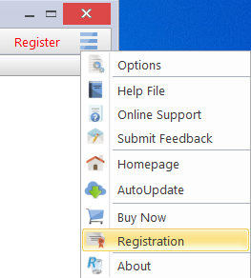
To activate Revo Uninstaller Pro online, you must first select that option in the Registration window (it is selected by default), and must have permissions to access the Internet, so it should be allowed in your firewall.
To open the Registration/Update Subscription Form, and enter the Serial Number and your Name you have to:
- Run Revo Uninstaller Pro.
- Click the Menu button.
- Choose Registration or Update Subscription.

Another way to open the registration window is to click the Register link, on the left of the Menu button.

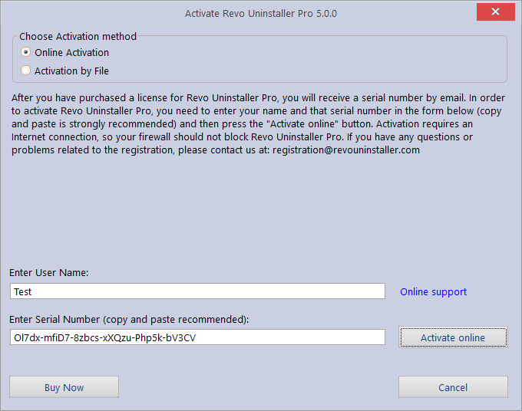

In the first field you need to enter a user name. The user name can be whatever you wish. In the second filed you need to enter your serial number.

IMPORTANT: the serial number contains lower and upper case characters, as well as numbers, and it is case-sensitive. Thus, we recommend that you copy and paste the serial number from the received e-mail, as that is easier, faster, and more reliable than typing it manually.

After you have filled out both fields, click the Activate Online button. You will see a text in the registration window saying that Revo Uninstaller Pro is contacting its server for activation.
The activation requires an Internet connection, because Revo Uninstaller Pro needs to contact our activation server to validate your License.

If your computer does not have an Internet connection, you have another option to activate Revo Uninstaller Pro - Activation by File.

7.2 - Activation by File

To activate or update a subscription of Revo Uninstaller Pro by file, first you must select that option from the Registration window.
To open the Registration/Update Subscription Form, and enter the Serial Number and your Name you have to:
- Run Revo Uninstaller Pro.
- Click the Menu button.
- Choose Registration or Update Subscription.

In the first field you need to enter a user name. The user name can be whatever you wish. In the second filed you need to enter your serial number.
After you have filled out both fields, click the Save File button. This will bring up a window that will allow you to save a .rupaf file with a name and location of your choice. After you save the file, send it to us by e-mail (to registration@revouninstaller.com ), and we will send you back the Unlock Key, which you must in turn enter in the same registration form, and click the Activate button.

After the activation is complete, restart Revo Uninstaller Pro to check the registration status in the title bar and the About window:
- the title bar of the main window of Revo Uninstaller Pro;
- Menu button -> About.
If the activation is successful you should see - Registered to [Your Registration Name].

7.3 - Deactivate

In case you want to use your Revo Uninstaller Pro’s license to another computer, or you are changing your current computer, you can transfer the currently activated license – deactivate it on your current computer, then activate it again on your other/new computer.

To start deactivation process follow these steps:
- Run Revo Uninstaller Pro.
- Click the Menu button (in the top right corner).
- Click Deactivate…

You will be prompted to confirm the operation, and then the deactivation will start. Note that the license deactivation requires an Internet connection. If you do not have an Internet connection, or your firewall blocks Revo Uninstaller Pro, the deactivation will be unsuccessful, and you will see a notification. In such a case, when you want to deactivate your license, but are unable to, please contact our support team for assistance.
Deactivating your license will disable the installed copy of Revo Uninstaller Pro on the computer, on which you have deactivated your license. Should you choose to activate on the same computer again, instead of activating on a different computer, you can do that. You will receive a message when you start Revo Uninstaller Pro on that same computer that the license was deactivate, and you can simply activate again.

8 – FREQUENTLY ASKED QUESTIONS (FAQ's) and TROUBLESHOOTING

8.1 - General Questions

I have used the contact form on your site, but I haven't received an answer from the support center! How long should I wait for support?

Our support team will contact you within 24 hours after receiving your message. The response time is usually between a few minutes and several hours depending upon the team's workload. If after 24 hours you still haven’t received a reply, then please resend your query and please ensure that your e-mail address is correctly written.

I am a registered user of Revo Uninstaller Pro 3.x, and have just bought an upgrade to version 4. Should I uninstall the old version before installing the new one?

We do not recommend that you uninstall version 3 before installing the new version 4 because you will lose both your current settings and other user data. The best approach is to install the new version, as it will simply overwrite the current one, and you will then keep your data and settings, just as happens with minor updates.

What is the difference between Revo Uninstaller Pro setup version and Revo Uninstaller Pro Portable?

The main differences between the two versions of Revo Uninstaller Pro are the licensing type and the portability of the Portable version. The standard (installable) version has a license that is per computer. This means that a license is purchased for a specific number of computers, but anyone who uses them can also use Revo Uninstaller Pro. The portable version has a license per user. This means that only one user is allowed to use Revo Uninstaller Pro, but can do so on an unlimited number of computers (just not simultaneously). The portable version is designed to be run directly from an external USB device (like a thumb drive), without leaving any traces on the computer’s hard drive or Registry, on which it is run. This allows you to always have a copy of the program with you.

I have Revo Uninstaller Freeware installed, and I bought the Pro version. Should I uninstall the Freeware version before installing the Pro?

Both versions of Revo Uninstaller – Freeware and Pro – are installed in different folders, and are totally independent of each other. They do not share common components or modules and so it is not a problem if you have installed the Pro version while the Freeware is still on your system. However, the Pro version is vastly superior and so you should not need the Freeware version anymore.

Why is "Pin to" missing on Revo Uninstaller Pro's shortcut and it cannot be pinned to Windows 7 taskbar or start menu?

This is because Windows 7 does not allow pinning programs containing the word “install” in their name. You can overcome this problem by creating a shortcut on your Desktop of Revo Uninstaller, and rename it to just “Revo”, or anything else that does not contain “install” as a word or part of a word.

Is Revo Uninstaller Pro compatible with 64-bit versions of Windows?

Yes, Revo Uninstaller Pro is fully compatible, and natively supports all 64-bit versions of Windows, starting with Windows Vista and up to the latest Windows 10.

Why should I use Revo Uninstaller Pro when I have a registry cleaner, and it fixes all errors in my Windows Registry?

There are tens of thousands of applications that leave a lot of unused data, such as registry entries, files, and folders in your computer. Not all registry keys left in your computer are errors, and third-party registry cleaners cannot therefore detect them. Leftover registry keys in combination with leftover files make a registry cleaners’ job impossible to fulfill, but Revo Uninstaller Pro helps you remove the leftover registry keys, files, and folders after uninstalling an application.

How can I close(exit) or move the Hunter Mode window?

To close the small blue target window, which appears in the upper right corner of the screen when you are in “Hunter Mode”, just rightclick and then choose Exit, or Open Main Window.

To move the blue target window, click and hold it with the middle (scroll) mouse button and then you can drag it to the desired position on your screen.

Revo Uninstaller Pro's window suddenly disappeared, and when I try to launch it again, I see an error that it is already running.

Most likely you have enabled Hunter Mode. Look for a transparent floating target icon on your Desktop or a Revo Uninstaller Pro icon in the system tray, right click either one, and select Open Main Window. If you do not see the aforementioned icons, check the Task Manager (Ctrl+Shift+Esc on your keyboard) for Revo Uninstaller's process, and close it. Then try launching Revo Uninstaller again.

I double clicked on Revo Uninstaller Pro's shortcut but nothing happens. Revo Uninstaller Pro does not start.

You can try to start Revo Uninstaller Pro from your Start Menu, if a shortcut is also available there. You can also try to start the executable (RevoUninPro.exe) directly from its folder: C:\Program Files\VS Revo Group\Revo Uninstaller Pro.
If both of the above fail, it is possible that a security program (antivirus/antimalware) is interfereing. Please add Revo Uninstaller Pro's folder and processes to the exclusion lists of your security software, and try launching Revo Uninstaller Pro again.

I tried using the AutoUpdate feature in Revo Uninstaller Pro but no connection could be established to www.revouninstaller.com.

Open the Windows Control Panel, go to Internet Options, and then the Advanced tab. Make sure the following two options are disabled:
- Warn if changing between secure and not secure mode
- Do not save encrypted pages to disk

Revo Uninstaller suddenly closes or stops working with an error message.

If this is a reoccurring issue, a more in-depth investigation may be required. Please contact us with detailed explanation and a step-by-step description how to reproduce the issue.

8.2 – Registration and Licensing Questions

Can I transfer my license for Revo Uninstaller Pro from if I am going to replace my computer?

Yes if you are a going to change your computer with a new one, Revo Uninstaller Pro version 4 offers the option to deactivate one’s license. To do so, click the Menu button (in the upper right corner), select “Deactivate License” and confirm by clicking “Deactivate”. You can now activate using the same serial number on the new computer.
For a more in-depth tutorial, you can find it here:
https://www.revouninstaller.com/user-tutorials/deactivate-revo-uninstaller-pro/
If you have already changed your computer and you no longer have access to it to deactivate your license, then please contact us via support@revouninstaller.com for further assistance. We treat such requests with priority, so it usually takes from a few minutes to a few hours, and always less than 24 hours.

What happens when my purchased subscription expires?

When your subscription expires, you will no longer be able to update to newer versions of Revo Uninstaller Pro. However, all versions released prior to the expiration date will remain functional. You can use any and all of these previous versions for as long as you like. You can download a specific version at any time from the release history page of Revo Uninstaller Pro here - https://www.revouninstaller.com/revo-uninstaller-pro-full-version-history/ , simply click the version number to download the desired version.
However, renewing your subscription is essential if you wish to update to newer versions.

Is the license of Revo Uninstaller Pro a lifetime license?

Purchasing a License for Revo Uninstaller Pro 4 or above includes free technical support and free updates while your update subscription is valid (not expired). The previous question and answer explain your options once your license has expired.
But remember, you can continue using your existing activated version, for which you have purchased a license, for as long as you want.
Dependent upon features in new versions, you can decide to renew your update subscription by purchasing an updated license (significant discounts will be applied).

I bought a license for Revo Uninstaller Pro for one computer. On how many computers can I activate the program?

Licensing of Revo Uninstaller Pro is per computer, so buying a license for one computer allows you to register the program on only one computer. If you want to buy a license for 3 or more computers, or if you are already our customer, you will be able to buy additional licenses at a discount. You could also consider the alternative and buy a license for Revo Uninstaller Pro Portable version. See the question and answers in the General Section FAQ's above.

What kind of license for Revo Uninstaller Pro do I need if I have installed more than one copy of Windows versions on my computer (dual/multi boot)?

You need a license for only one computer as all your Windows installations are on the same computer. You should not have problems registering the program on any of the different program versions of Windows.

I cannot activate online because the Activate online button is gray. What do I do?

First, please make sure that you have entered a user name. It can be whatever you wish, but the field is mandatory.
If you have entered a user name, please make sure that you have entered your serial number exactly as you have received it.
If you are certain the serial number is entered correctly, please make sure you have downloaded the correct version of Revo Uninstaller Pro: installable (non-portable) or portable.
If the issue persists, please contact us via e-mail for further assistance.

During the registration process, I saw a message "Registration failed". How do I proceed?

If you have a registration problrm and you see this message, then it should be followed by a sentence with a reason for the problem, or with an error code. Please contact our support team with the information about the failed registration, and we will help you resolve the problem.

During the registration process I'm seeing an "Server Busy" error message with options to "Switch to..." and "Retry".

Please click 'Retry', wait 10-15 seconds, then click the button again. Repeat this a few times, and the registration should be successful. If the issue persists, please contact us for further assistance.

Will I be charged automatically when my subscription expires?

By default, the Annual Update subscription option is deactivated. It must be explicitly enabled by you, the customer, during purchase. You can check if it is enabled in the confirmation e-mail, containing your license details.
If you have activated the Annual Update Subscription option, you will receive a reminder 14 days prior to the automatic charge for the updated subscription license.

How do I update/extend my subscription period?

Open your activated Revo Uninstaller Pro, navigate to the Main button -> Update subscription, and enter your newly provided serial number to extend your subscription.

Can I extend my subscription before the expiration date?

Yes, you can extend your subscription at any time. After the new purchase is completed you should use the Update subscription option. This will allow you to extend your current subscription by entering the new serial number that you have received.

How can I check when my subscription expires?

Open Revo Uninstaller Pro, and click the Menu button -> About. The About window will display both the expiration date and the remaining days of your active subscription.

Why have I been charged for renewal yet Revo Uninstaller Pro shows that my subscription has expired?

A new serial number was generated and sent to you after the renewal was completed. You will have to use the Update Subscription option in Revo Uninstaller Pro with your new serial number in order to renew your subscription.

Is there a difference between a "new" license and a "renewal" license?

The only difference is the intended usage of a license. Any newly purchased license can be used to either activate on a new/additional computer, or to update/extend the subscription period of a previously activated copy of Revo Uninstaller Pro 4.
Please note that the subscription period of a license starts at the moment of purchase, not when first used.

Can I renew for fewer or more devices than my previous/current license?

Yes. Since all licenses are completely independent of each other, you can purchase a new license (renewal) for as many computers as you want. Previous purchases do not limit new purchases in terms of type of license, quantity, or subscription period.

8.3 - Uninstall (remove) Program Related Questions

How do I uninstall programs with Revo Uninstaller Pro?

Before uninstalling a program, make sure that it is not running. Check the system tray (in the Taskbar near the clock) for any icons belonging to the program you want to uninstall. If there, try right clicking them, and look for an option like “Exit”, “Quit” or something similar. Then start the most popular Uninstall procedure as described in chapter - 3.4 or get more information here: How Revo Uninstaller Pro Works

How do I uninstall a traced program with Revo Uninstaller Pro?

If you have monitored the installation of a program with Revo Uninstaller Pro, then the best way to uninstall it is to use its' log created by Revo Uninstaller Pro. Before uninstalling a program, make sure that it is not running. Check the system tray (in the Taskbar near the clock) for any icons belonging to the program you want to uninstall. If there, try right clicking them, and look for an option like “Exit”, “Quit” or something similar. To continue, open the Traced programs module as described in chapter 3.2

I am tracing an installation of a program with Revo Uninstaller Pro, but the program's installer asks me to restart the computer. How should I proceed?

If you see this message or a request for a reboot, our advice is to stop the tracing process, and save the log with Revo Uninstaller Pro (on a system restart if the tracing of Revo Uninstaller Pro is active, then it will save the log with a default name automatically), and now restart your computer. For most programs, you will have a reliable log file, as in such cases all the program data is already installed, and the program needs a reboot to start its services or modules that are going to be started on every Windows start up.

How do I uninstall a program if I see that there is a log for that program in the Logs Database?

For a full explanation, please refer to chapter 4.1

Is there a way to undo an uninstallation of a program?

Reinstalling the program is the first and easiest solution. Other options are to use Windows Restore or the Backup system of Revo Uninstaller Pro as described in chapter 3.7

How can I stop/remove a program from the Windows system tray?

You can use the command “Kill” or Kill and Delete” of Hunter Mode feature as described in chapter 4.5

Why can't I uninstall programs without admin rights on Windows Vista/7/8/10?

Because uninstalling programs involves removing files, folders, and Registry entries from various protected system locations on your hard drive and Registry. The standard user account is designed to only have privileges to run/use most programs.

How can I remove a program, which when I try to uninstall using Programs and Feature or Revo Uninstaller Pro, I see the same error message?

Most likely, this error message is generated by the built-in uninstaller of the program you want to uninstall, which both the Programs and Features applet and Revo Uninstaller Pro try to run during the selected uninstall procedure. In most cases, Revo Uninstaller Pro can handle the uninstall process even if the built-in uninstaller of the program is not functioning properly. In that case, you should start the uninstall procedure with Revo Uninstaller as usual, and when you see that error message, you can simply skip (ignore) it, click the Scan button to start scanning for the leftovers of the program, and then continue as normal.

How can I remove a program, which is not listed in Programs and Features (Add or Remove programs) or Revo Uninstaller Pro?

If the program is not listed in Revo Uninstaller Pro, then try our Forced Uninstall feature – chapter 4.3

How do I proceed if the program's own built-in uninstaller asks to reboot the computer during an uninstall procedure?

The best approach is to decline the reboot request, continue the uninstall procedure as normal, and then finally reboot your computer. If you were unable to decline the reboot request, and your computer restarts, don't worry. The next time you start Revo Uninstaller Pro it will prompt you to continue the uninstall process.

I uninstalled a program with Revo Uninstaller Pro but there are still leftovers.

Some files may not be deleted immediately if they are in use by another process. Such files are scheduled for deletion upon reboot so please restart your computer. If the leftover are still present, please try our Forced Uninstall feature – chapter 4.3

Can I use Revo Uninstaller Pro to uninstall accumulated updates for Microsoft Windows?

If any updates are listed in Revo Uninstaller Pro, then you should be able to uninstall them without issue. However, their installation and removal is extremely critical for the operating system, and it should be handled only by the built-in functionality in Windows.

I used Programs and Feature application to uninstall a program several months ago. Can Revo Uninstaller Pro still find possible leftover items so I can delete them?

If already uninstalled, please try our Forced Uninstall procedure – chapter 4.3

I am trying to uninstall a program, but during the uninstallation procedure, the built-in uninstaller of the program is reinstalling/repairing it instead of uninstalling it. How do I proceed?

Please use our Forced MSI Uninstall feature as described in chapter 4.4

I am trying to uninstall a program but its built-in uninstaller's window does not appear or start when it is supposed to start after I click the Uninstall button?

If built-in uninstaller of a program does not appear, please check if its window isn't underneath other windows that you may have opened, as sometimes uninstallations are launched in the background. You can check the Taskbar for any newly appeared windows.
If the built-in uninstaller doesn't start properly and you see an error message, most likely, it is generated by the built-in uninstaller of the program you want to uninstall, which both the Apps and Features applet and Revo Uninstaller try to run during the uninstallation procedure. In most cases Revo Uninstaller can handle the uninstallation process even if the built-in uninstaller of the program is not functioning properly. In that case, you should continue the uninstallation procedure with Revo Uninstaller as usual, and when you see that error message, you can simply skip (ignore) it, click the Scan button to start scanning for the leftovers of the program, and then continue as normal.

8.4 - Other Questions

What is the Logs Database?

The module Logs Database is fully described in chapter 4.1

Can I use a log from the Logs Database to uninstall a different version of the program from the log?

It depends upon the program, and how much it has changed across different versions. In most cases, you should be able to properly uninstall a program with a version similar to the one of the log. For example, if you have Skype 5.2 installed on your computer, you should be able to uninstall it properly even using a log for Skype 5.1. That is because of the “Advanced Uninstall” technology applied when a traced program is uninstalled through a log. You can get more information in chapter 4.6

How can I scan with the Junk Files Cleaner for a specific file type?
Go to Menu button -> Options -> Junk Files Cleaner -> General, and check if the specific file type is in the list, and if it is checked. If the file extension is not listed, click the Add button, enter the specific file type in the newly appeared window, and click OK to confirm. Start the Junk Files Cleaner, and click the Scan button to start scanning.
How can I stop programs that start automatically on Windows startup?
In the Autorun Manager, you have to uncheck the program you want to disable. Conversely, to enable it, simply check it back again.

